**Laboratory #4: Spatial Analysis in Vector**

**Purpose:** The purpose of this lab is to provide you with an introduction to basic spatial analysis concepts and capabilities in geographic information systems science.

**Learning Outcomes:** By the end of this lab, students will be able to:

* Execute a spatial query.
* Differentiate between a spatial query and an attribute query.
* Undertake a date-based query.
* Assess centrographic measures of a point pattern.
* Create and explain a kernel density (KDE) estimate of a point pattern.
* Use point-in-polygon operations to calculate density.
* Operationalize union overlay.

**Procedure:**

1. Read and work through the examples.
2. Answer the questions at the end of the lab.

**Data/Materials:**

Provided with laboratory outline:

* Lecture 6.
* This document, datasets in the LECTURE7.zip from Brightspace.

**Supporting Documentation:** Lecture 6.

**Assignment:**

* Answer the questions (#1-5).
* The total marks available for this assignment = 15 marks for 12.5% total course grade.
* All lab assignments must be completed and handed in individually.

**Format:**

* Students will hand in questions with completed answers.

**Tables and figures should be produced to the standards of the Department of Geography, Environment and Geomatics, University of Ottawa.**

**For guidelines on proper formatting and presentation of tables and figures, please see the introductory section of this lab manual.**

This section presents examples of things you will need to know to address the questions you will be handing in for marks. Your task is to review and repeat the examples in this section and then determine which of these are relevant to helping you address the questions that are at the end of the exercise.

Q1: How do I undertake a spatial query?

In Lecture 5 and Exercise 2, you learned about structured query language (SQL) and how to use queries to answer questions about attribute data using “Select Layer By Attribute” in ArcGIS. A spatial query employs the “Select Layer By Location” dialog and usually two or more spatial layers within the same spatial domain. For example, suppose we have two point layers: one layer called **Crime**[1], shows the locations of crimes and the second layer called **Schools** shows the location of schools (Figure 1):

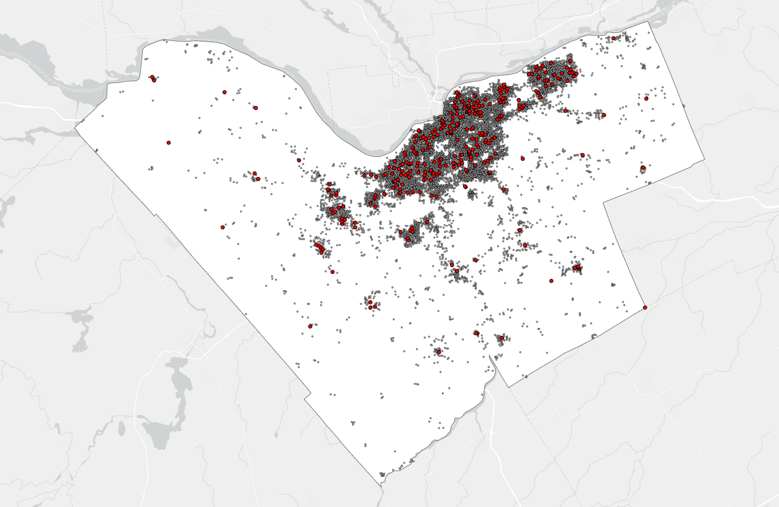

Figure 1: Two layers for use in spatial and attribute query denoted by different colored points.

We might want to select all crimes within 250 m of schools in Ottawa. The most efficient way to complete such a task is to use the “Select Layer By Location” tool to select all Crime points within 250 m of Schools.

1. Add Crime and Schools to ArcGIS Pro (from the Ottawa feature dataset in the OTTAWADATA geodatabase in the Lecture7 folder).
2. In the Map tab, find the ‘Selection’ group and Click on “Select Layer By Location” to open the Select Layer by Location tool:

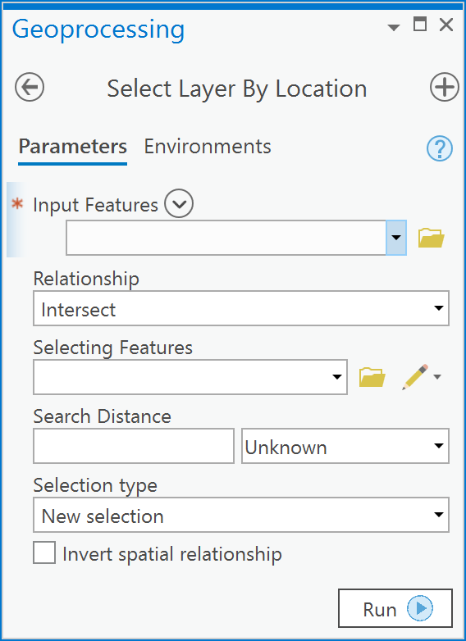

1. In the dialog, the Input Features are the target of the selection and here because we want to select all crimes within 250 m of a school, the feature class Crime should be selected under ‘Input Features’. Under ‘Relationship’ choose Within a distance. Under ‘Selecting Features’ choose Schools. Type in 250 within the ‘Search Distance’ input box. Click Run.

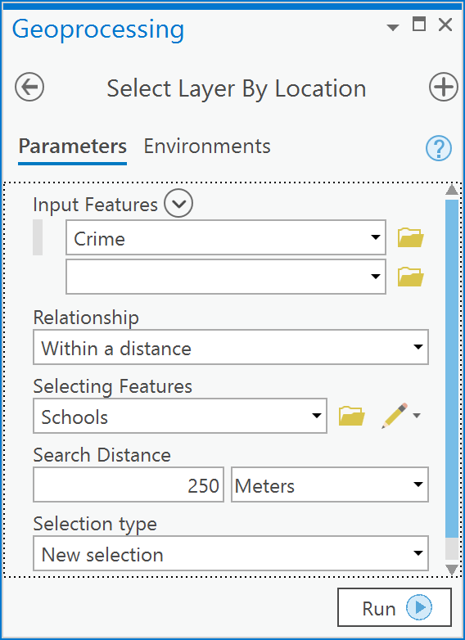

1. You should see a result that looks like the following:

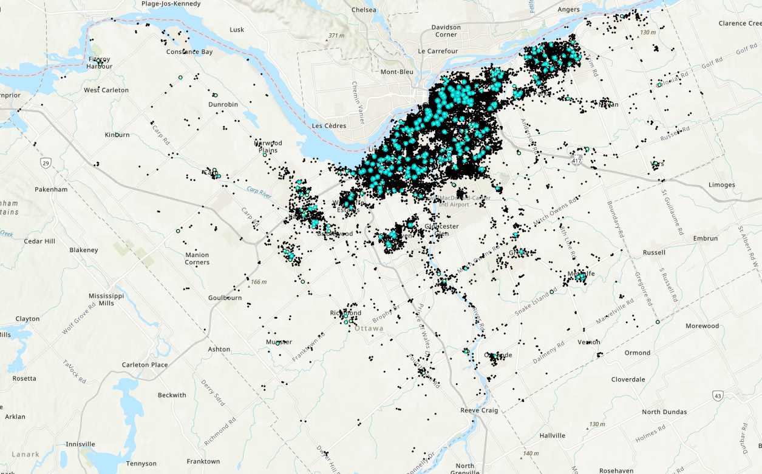

You have now undertaken a spatial query. You have used a spatial relationship - “Within a distance” - between two feature classes within the same spatial domain to select features within one of the participating feature classes. The “Within a distance” operation “creates buffers using the buffer distance around the source features and returns all the features intersecting the buffer zones.” (ESRI Help).

Q2: How are SQL and spatial queries (select layer by location) related?

Using Select Layer By Location with Select Layer By Attribute together is a powerful combination. For example, you could address a question such as: *How many assaults have occurred within 250 m of a school in Ottawa*? Answering this question requires a spatial query and an SQL query together:

1. Repeat Example Question Q1 to select all crime within 250 m of each School.
2. Open the attribute table for the Crime layer.
3. Notice that there are 6251 Crime points (out of 25454) selected. Also, notice that there are other attributes such as “SUMMARY” which provides information on the type of crime for each point:

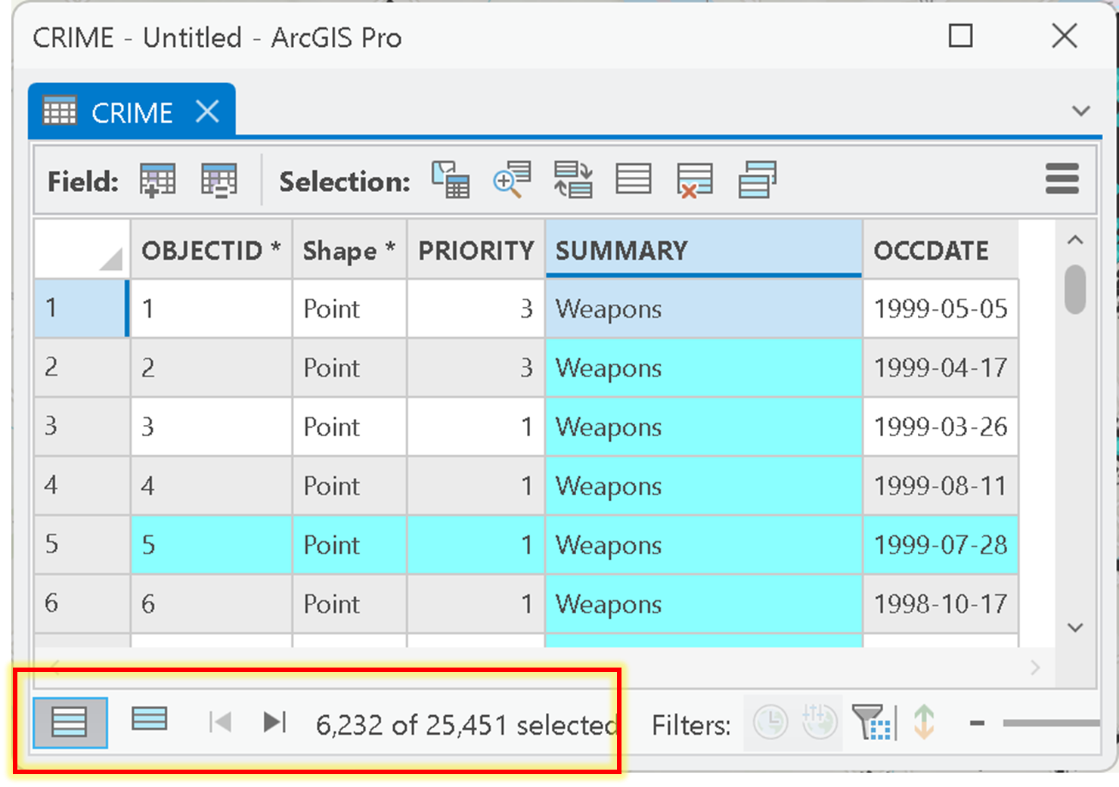

1. So, *from* the 6251 selected features that resulted from the spatial query in Example Question Q1, you now want to select only those that are ‘Assault’. To make this selection, keep the Crime table open and go to the Map tab and find the “Selection” group and choose Select Layer By Attribute.

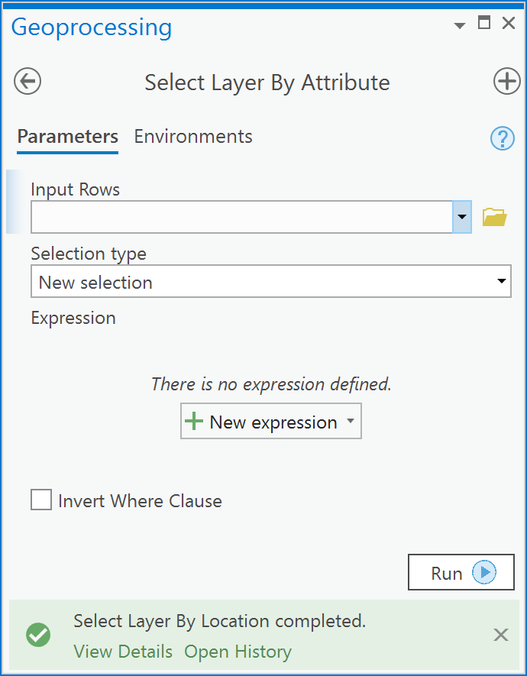

1. Examine the Select Layer By Attribute dialog box below and make yours look the same, the key here is to tell ArcGIS that you want to ‘**Select subset from the current selection**’ so that only those points that meet the criteria of having a SUMMARY type equal to ‘Assault’:

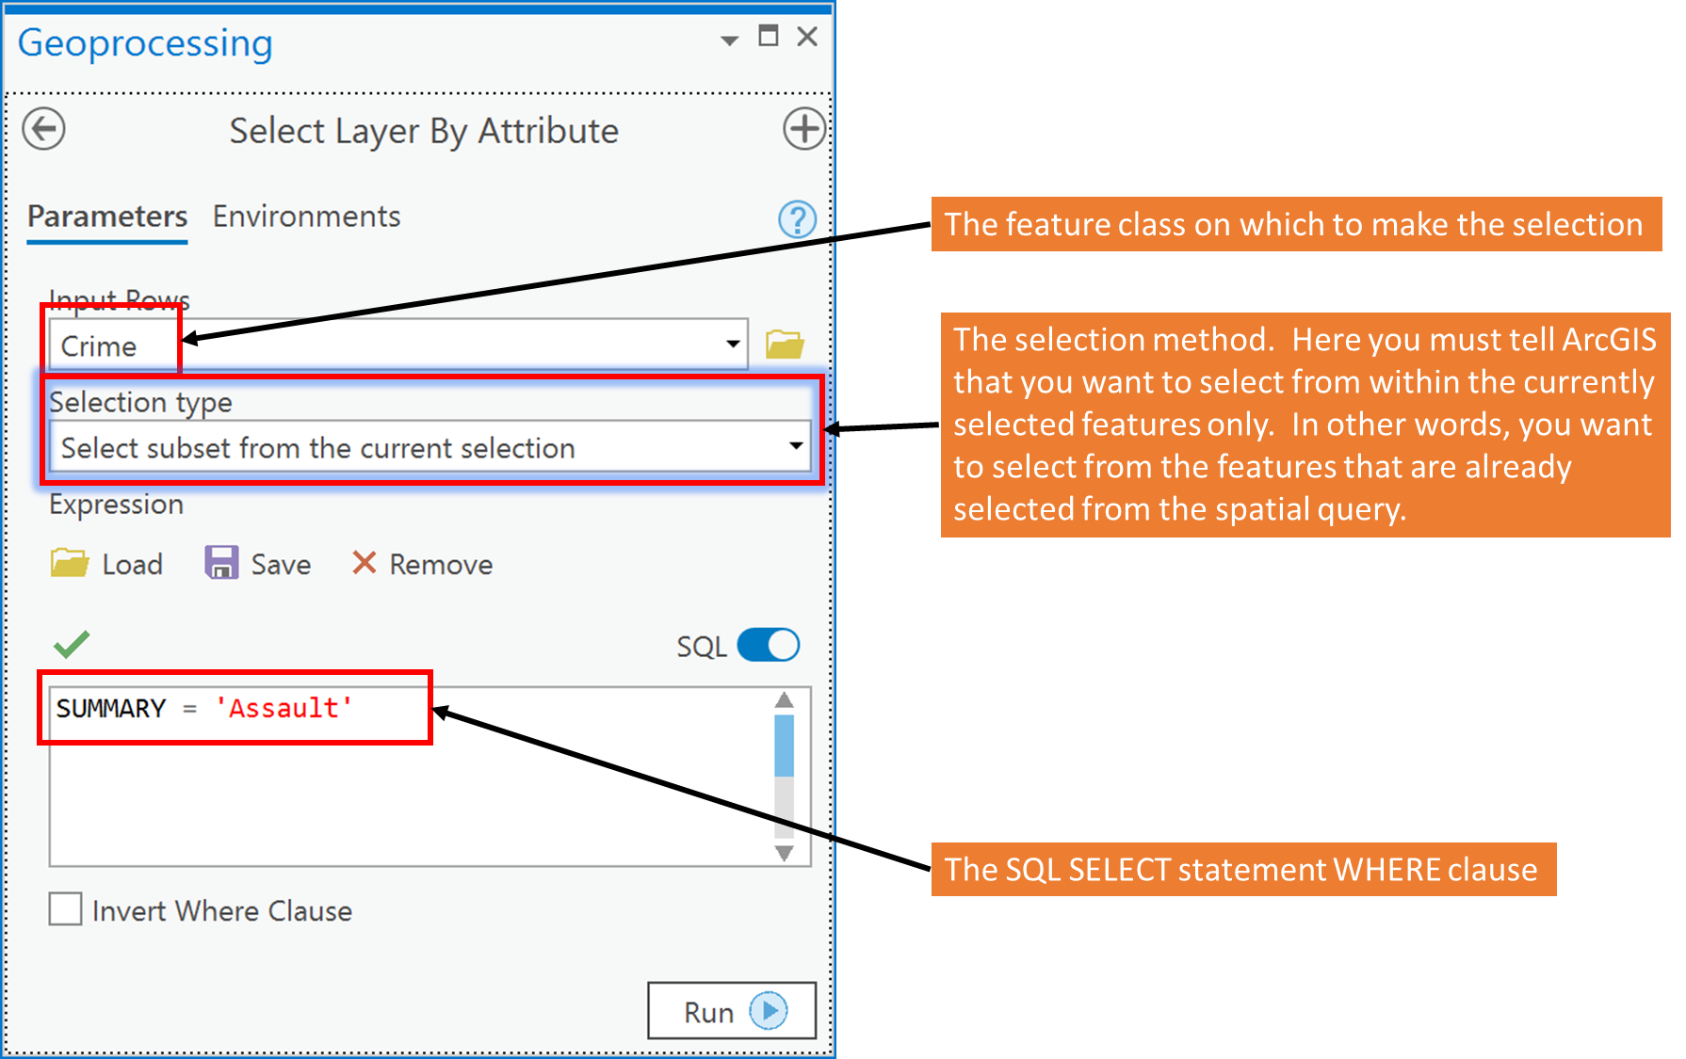

1. Click Run.
2. Examine the attribute table for Crime, you can see now that there are 909 assaults within 250 m of schools in Ottawa. This represents about 14% (909/6232 * 100) of the total crimes within 250 m of schools.

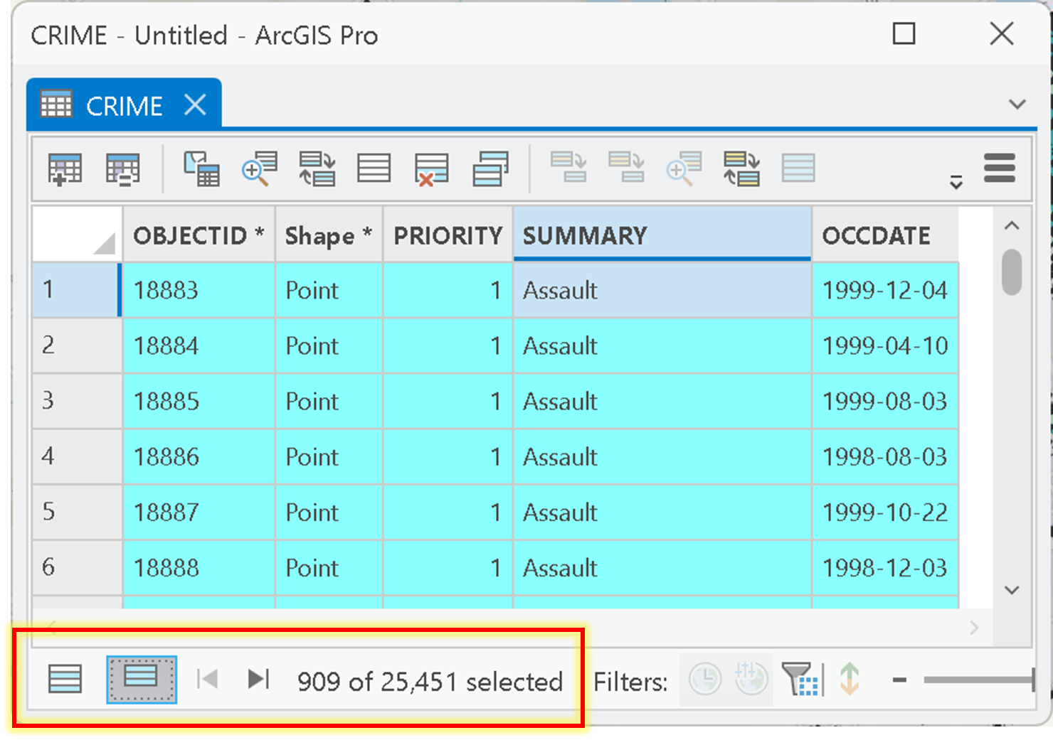

Q3: How do I create an SQL query with a date field?

Time and Date are implicit attributes of spatial data. Why? Because all spatial data is collected at a given date and time. Some spatial data, like the Crime layer, has information on the date for at which an observation occured. In the case of the Crime layer, there is an OCCDATE field that tells us the date at which a given point observation occurred. The date format is given as:

month/day/year

So, for example, a point with an OCCDATE of 7/1/1998 means that the event in question occurred July 1st, 1998. To query a Date field in a file geodatabase or shapefile you need to precede the date value with the keyword **date** (without quotes), for example, if I wanted all crimes that occurred on July 1st, 1998, I would enter the following in the Select Layer By Attribute dialog:

OCCDATE = date '07/01/1998'

This would select all records (and features) that occurred in July 1st, 1998. For example, make the above query on the Crime layer using the Select Layer By Attribute dialog:

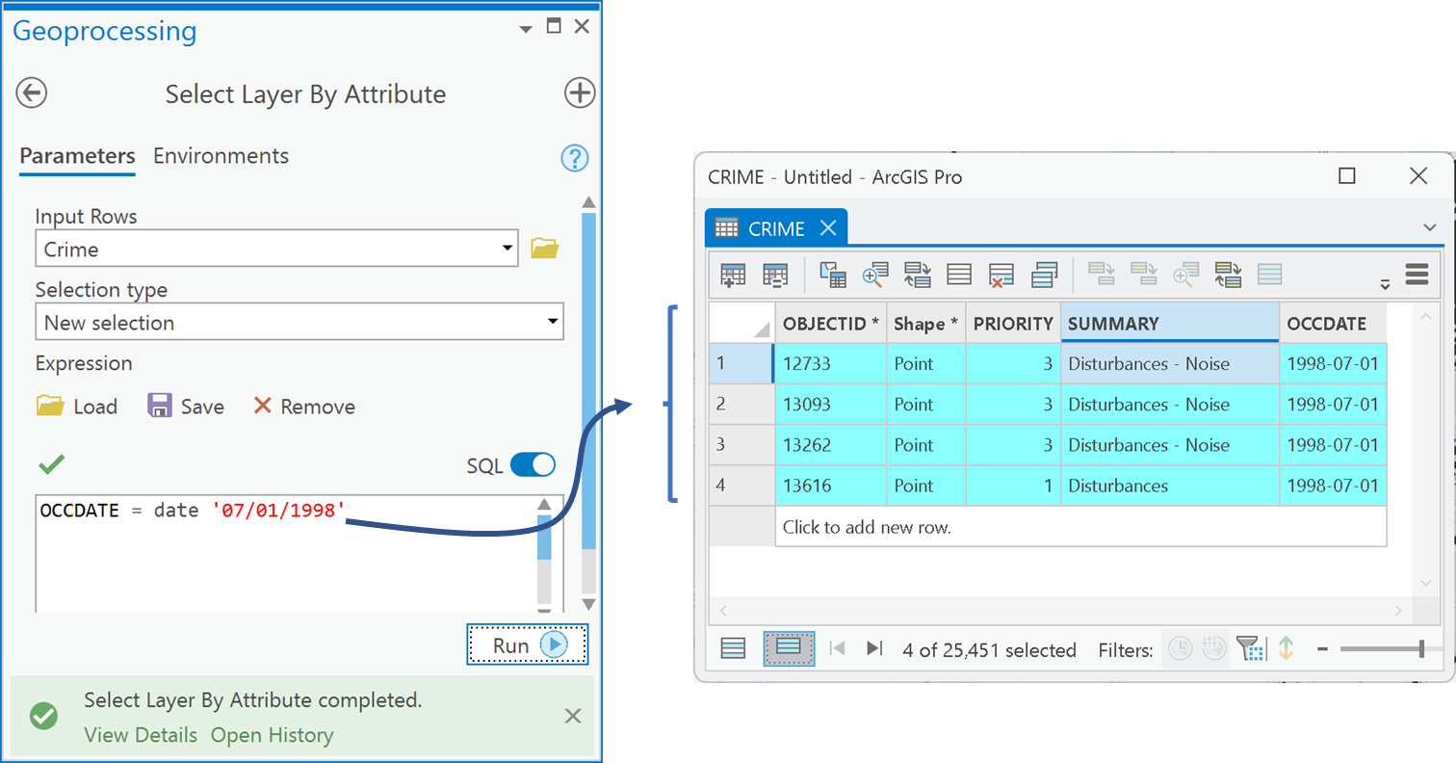

You can also query for all dates within a range of dates using relational operators like <,>,<=,>=. For example, if you want all crimes within the month of July 1998 you could use the following SQL statement:

OCCDATE >= date '07/01/1998' AND OCCDATE < date '08/01/1998'

This would select all dates in July since the “<” symbol is used to ensure that no date, after or including August 1st is selected.

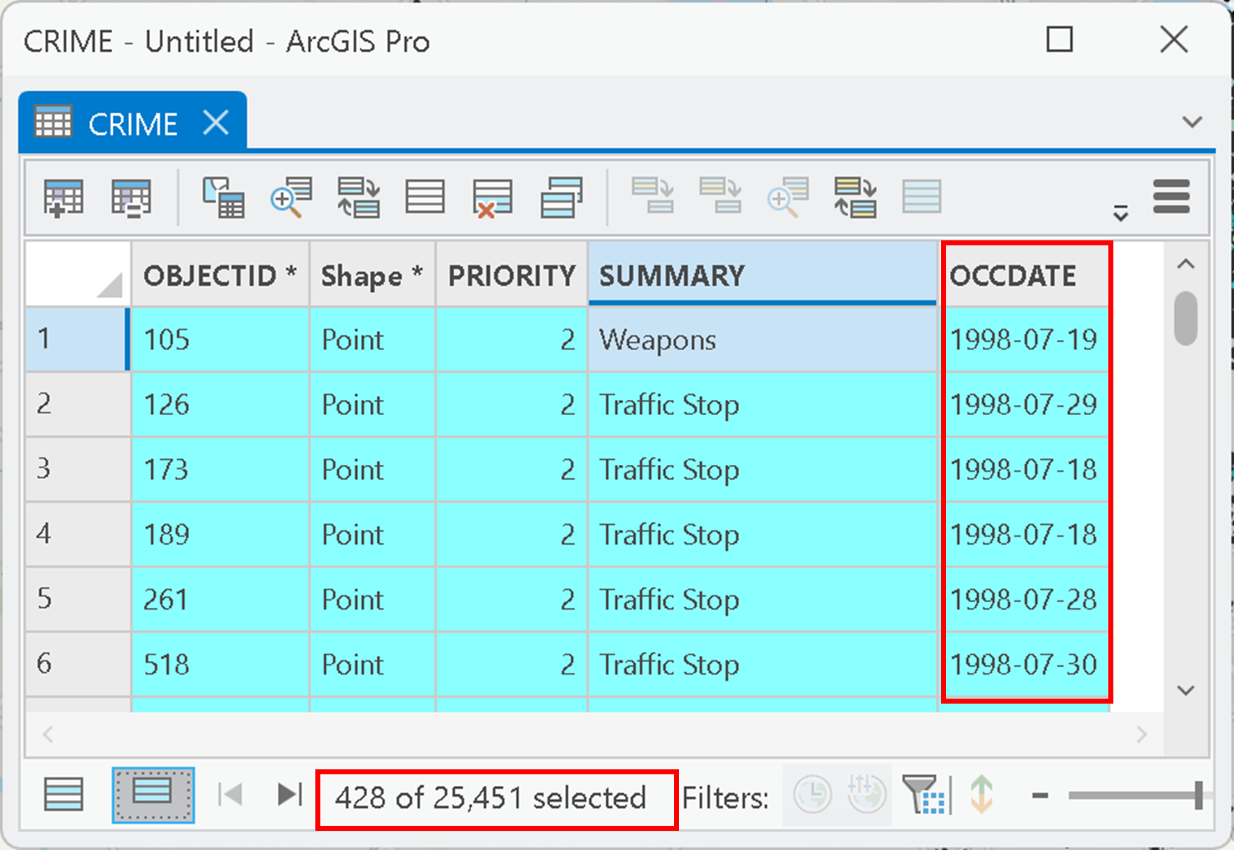

You can also use date conditions together with conditions based on other fields. Suppose that you wanted to get all assaults in the month of January 1999, you could use the following statement:

OCCDATE >= date '01/01/1999' AND OCCDATE < date '02/01/1999' AND SUMMARY = 'Assault'

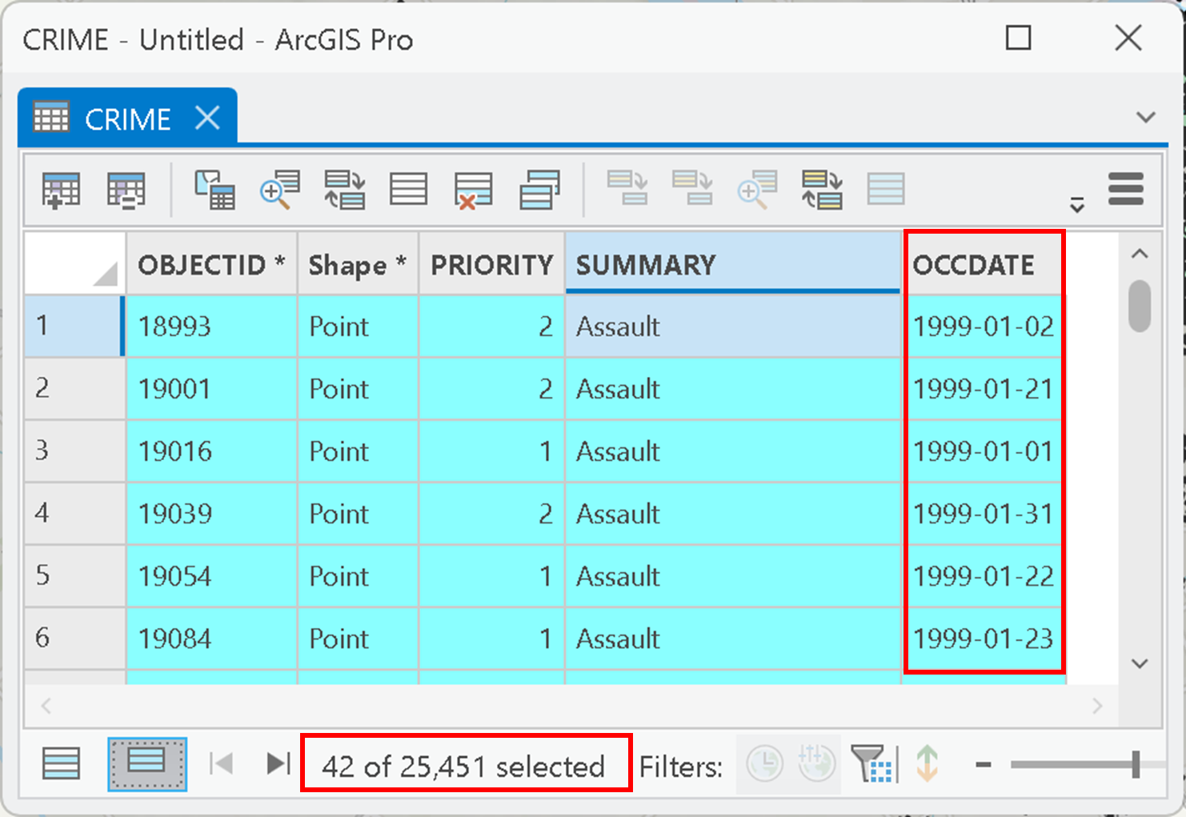

Q4: How do I undertake centrographic measures for a point set?

In Lecture 6 you were introduced to centrographic measures of point sets. These measures include the *mean center*, *standard distance (SD)* and *standard deviation ellipse*. These centrographic measures are often used for comparing distributions of point phenomena at different times within one area or spatial domain (Figure 2). Figure 2a illustrates a south-east shift in the mean center of assault crimes in Ottawa between January and June 1999. Moreover, the standard distance circles for these two months indicate overall dispersion of assaults remained the same as indicated by the size of the SD circles (Figure 2a). However, the standard deviation ellipses for the two months indicate that, for January 1999, that the directional dispersion was slightly N-S direction and the orientation shifted more NNE-SSW in to July 1999 (Figure 2b).

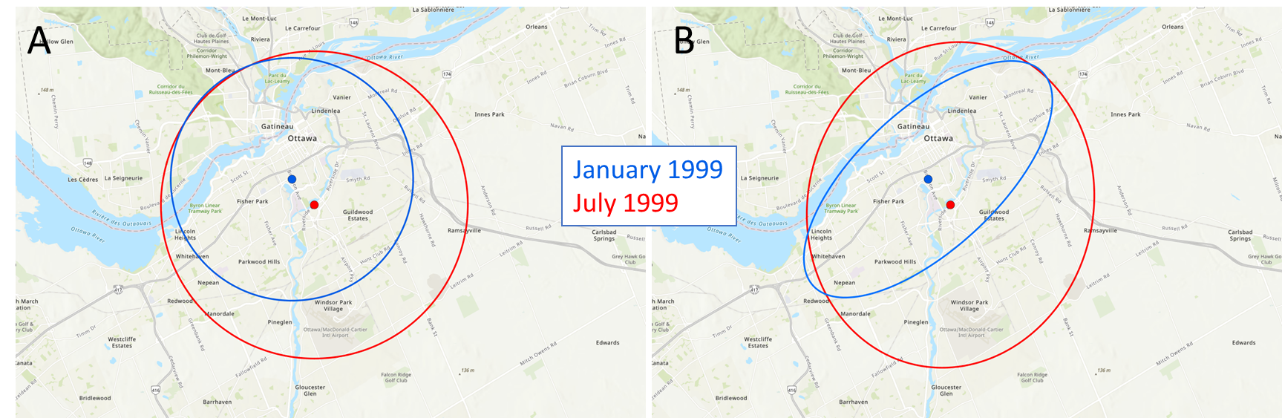

Figure 2: A) Standard distance circles and B) Standard deviation ellipses for Assaults in Ottawa 1999.

Suppose you wanted to compare the dispersion of assaults in Ottawa between January 1999 and February 1999. To do this analysis you would:

1. Use Select Layer By Attribute to query for assaults in January 1999:

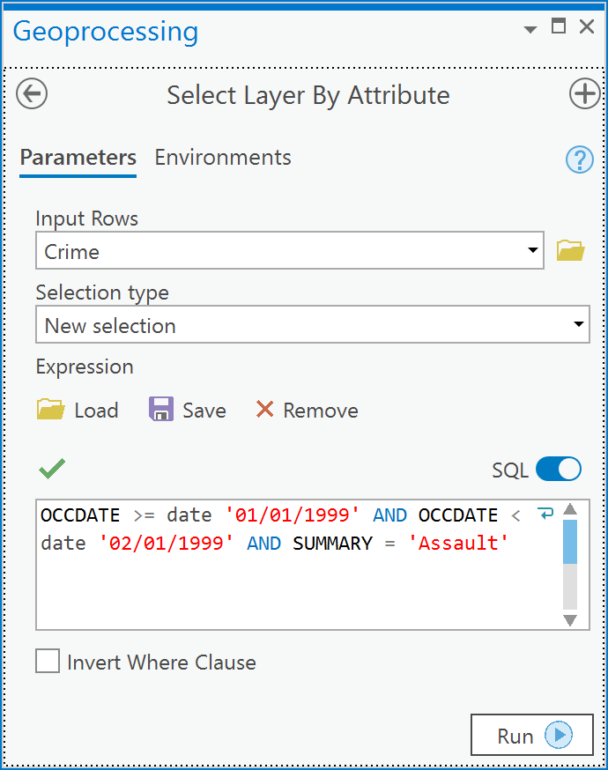

1. Go to Spatial Statistics tools -> Measuring Geographic Distributions -> Standard Distance,

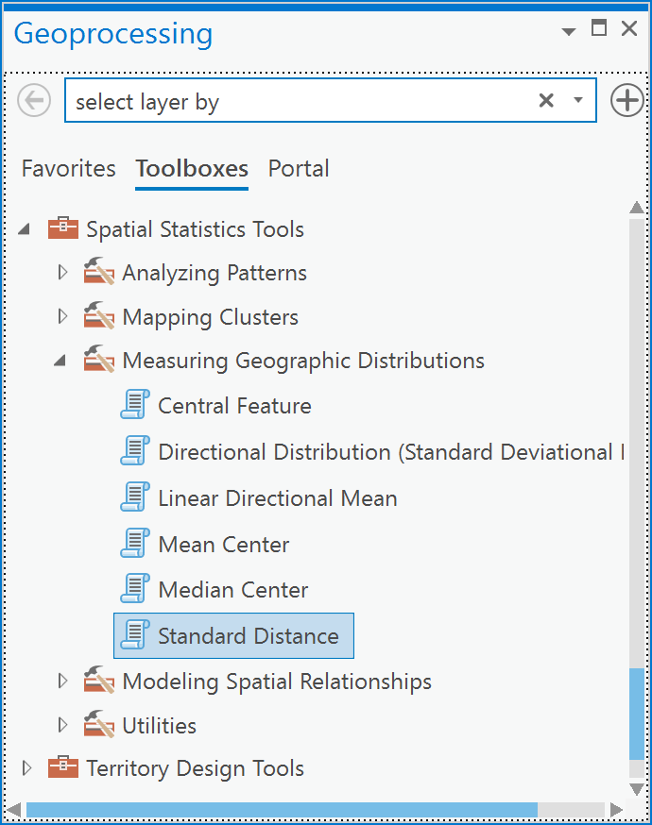

1. In the ‘Input Feature Class’ drop-down choose Crime and Click Run.

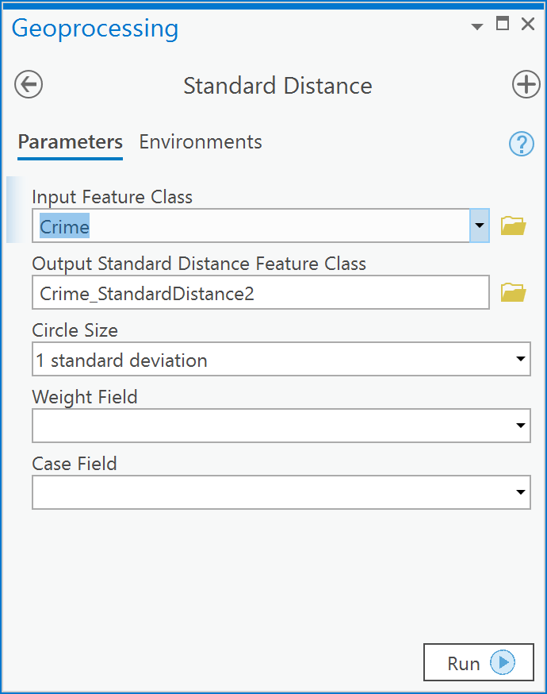

1. The result is a polygon shapefile that shows a circle with 1 standard distance that represents the dispersion of assaults in January. Because we used a query to select a subset of features from the entire crime dataset, **only the selected records were used** in calculating the standard distance. This is the default behavior of almost all tools, because when there is a selection within a layer in ArcGIS and that layer is used in a Tool, the tool only operations on the selected features.
2. Next, repeat 1 to 3 for February 1999.
3. The result (Figure 3) will show 2 standard distance circles on your map, one for January 1999 assaults and 1 for February 1999 assaults:

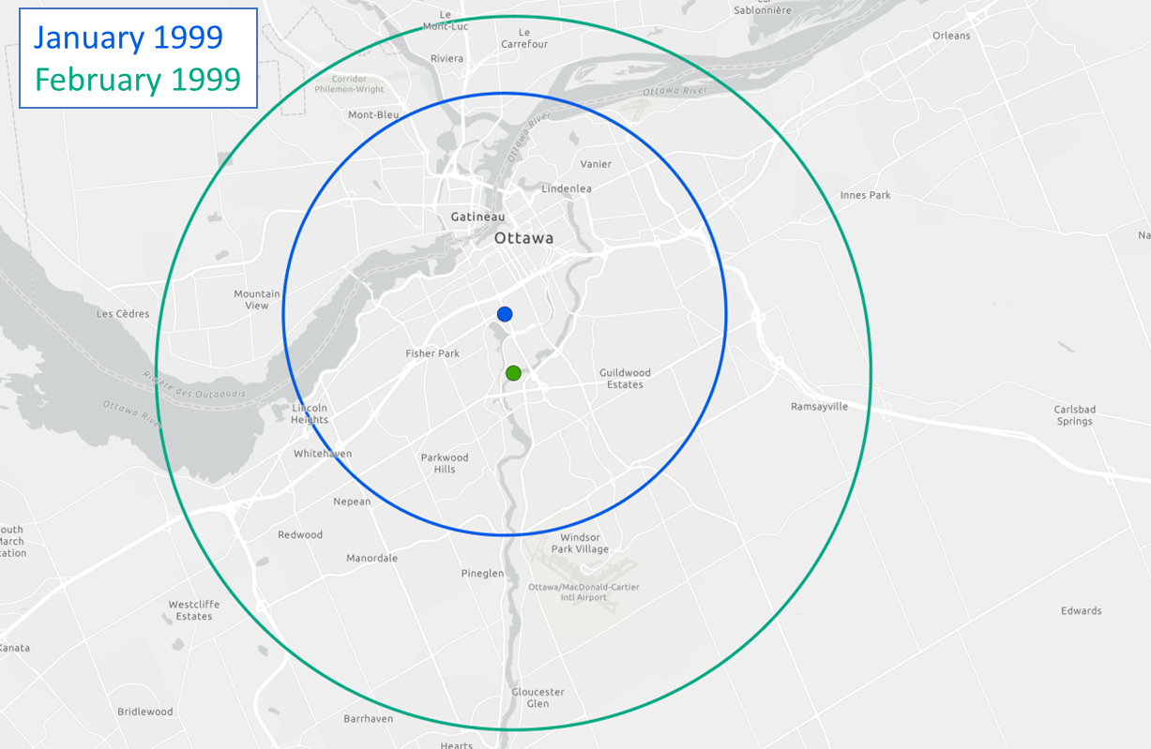

Figure 3: Standard distance circles comparing dispersion of assaults in January and February 1999 within Ottawa

Assaults are more *dispersed* in February when compared to January 1999 as shown by the larger standard distance circle in February (Figure 3). Since the centers of each circle are not coincident there seems to be a shift of the *mean center* of activity towards the east in February.

We could have used the Python pane instead to undertake the above analysis, for example to acquire all the centrographic measures – mean center, standard distance and standard deviation ellipse - for January assault crimes,

*# Create string variables to hold  
# the SQL where clause as well  
# as the names of the input and  
# output layers*input_lyr = **'crime'**out_mean_center = **'january_mean_center'**out_sd = **'january_sd'**out_sde = **'january_sde'**query_string = **"OCCDATE >= date '01/01/1999' AND OCCDATE < date '02/01/1999' AND SUMMARY = 'Assault'"***# Select crimes within the date range*SelectLayerByAttribute(input_lyr, where_clause=query_string)  
  
*# Create a layer with a point for the mean center*MeanCenter(input_lyr, out_mean_center)  
  
*# Create a layer with a circle for standard distance*StandardDistance(input_lyr, out_sd)  
  
*# Create a layer with a standard deviation ellipse*DirectionalDistribution(input_lyr, out_sde)

The advantage of the above code is that when we want to re-run the python statements for February, all we must do is change the string variables at the top, mainly replacing ‘january’ with ‘february’ and modifying the month’s in the SQL where clause:

input_lyr = **'crime'**out_mean_center = **'february_mean_center'**out_sd = **'february_sd'**out_sde = **'february_sde'**query_string = **"OCCDATE >= date '02/01/1999' AND OCCDATE < date '03/01/1999' AND SUMMARY = 'Assault'"**SelectLayerByAttribute(input_lyr, where_clause=query_string)  
  
MeanCenter(input_lyr, out_mean_center)  
  
StandardDistance(input_lyr, out_sd)  
  
DirectionalDistribution(input_lyr, out_sde)

Q5: How can I visualize the spatial variability in point intensity within a region?

In Lecture 6 you were introduced to the kernel density estimate (KDE). A KDE shows the variation in intensity, called lambda, $λ$, across a spatial domain. A KDE is represented as a kernel density surface that is created from a set of points. The KDE is created by placing a 3D mathematical function, called a kernel, whose maximum value is centered at the location of each point in a pattern. Then, the z-values (height values) of all the 3D mathematical functions (the kernels) are added together (Figure 4) at each location in space to create the KDE surface. This process results in a raster layer that shows high values where there are lots of points and lower values where there are fewer points (Figure 4).

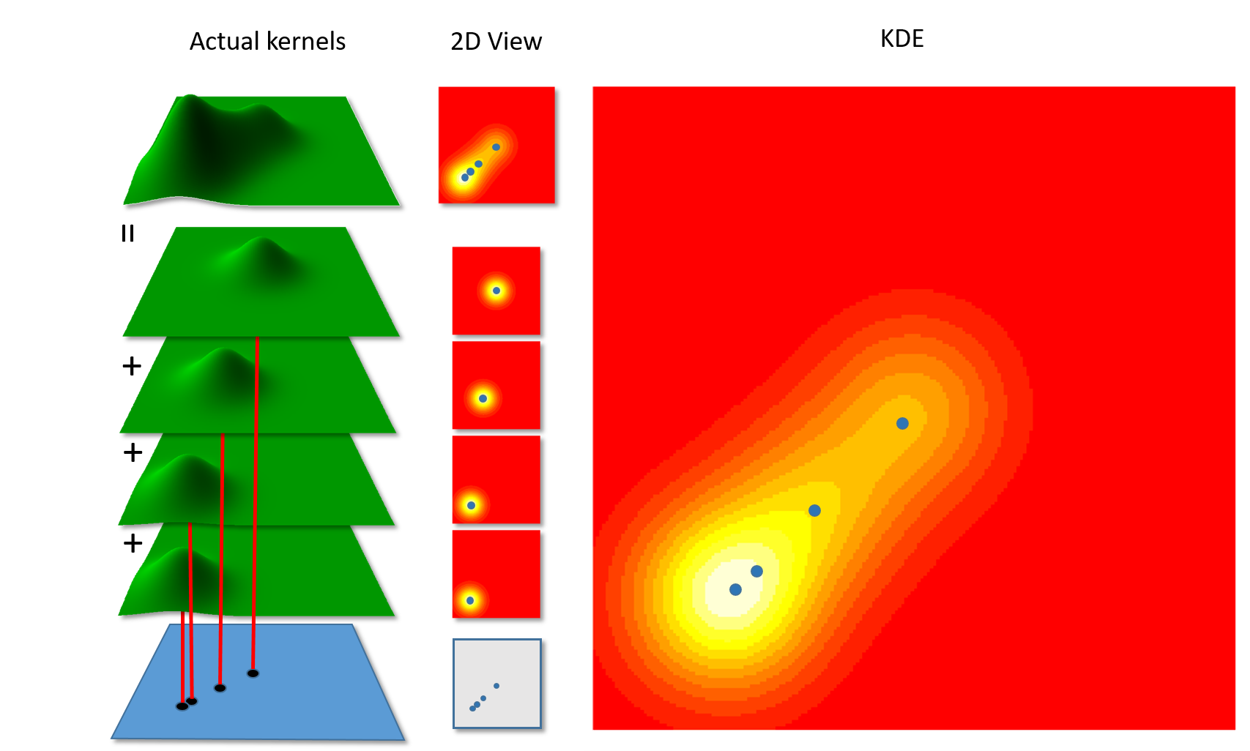

Figure 4: The creation of a KDE. Gaussian 3D kernels (left) placed on top of each point in a point pattern are summed at each location within the study region.

For example, you could create a KDE for assaults in January 1999 and compare this to the KDE for assaults in February 1999:

1. You will need to ensure in ArcGIS that you load the Spatial Analyst extension.  To do so, click on the Project tab and then look under ‘Esri Extensions’ for Spatial Analyst – you may need to scroll down. If there is a checkbox there check it and return to the map tab, if there is no checkbox and the word ‘no’ appears, then click on the button that says, ‘Configure your licensing options’. You will see a list and again find the one that says Spatial Analyst. Thereupon, you should see a checkbox. Check it and click OK and return to your map tab. If there is no checkbox then choose the line that contains Spatial Analyst and click the Authorize button. Once finish, click OK and return to your Map Tab. Yours will be somewhat similar or identical to what you see below:

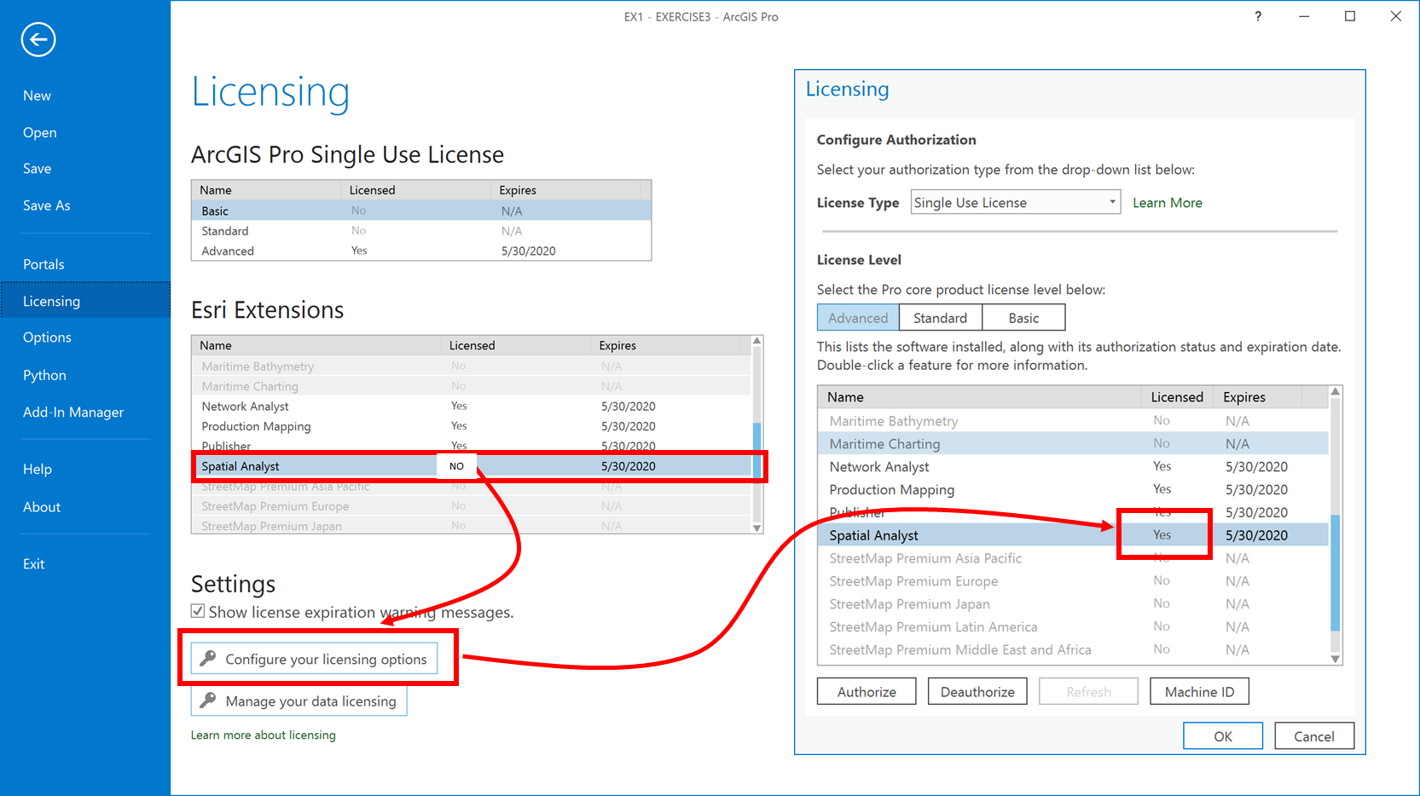

1. Now, add the layer called Boundary from the OTTAWADATA feature dataset to your map.
2. You need to set a number of key Environment parameters in order to work with the Spatial Analyst tools in the geoprocessing pane. Specifically, you must set the Processing Extent, Cell Size and Analysis Mask within the ArcGIS Pro’s Environment settings. Go to the Analysis tab and in the Geoprocessing group click on the Environments button and set your parameters to the same as you see in 1,2,3 below:

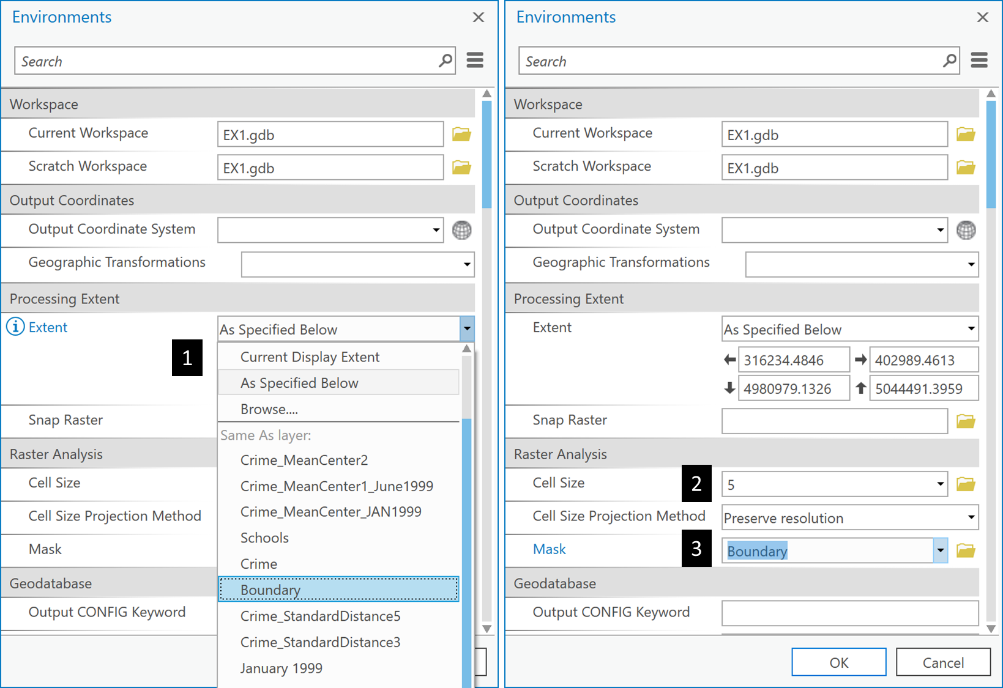

1. Now, select all Crime points that are assaults in January 1999 as you did in EX Q4 above:



1. Then go to Spatial Analyst Tools -> Density -> Kernel Density. Under ‘Input point or polyline featuers’ choose Crime. Under ‘Output raster’ call it ‘january’. Here the ‘Search radius (optional)’ is the bandwidth setting. ArcGIS calculates a reasonable default for most cases using Silverman’s Rule (see help file). Ensure all other settings are as you see below and click Run:

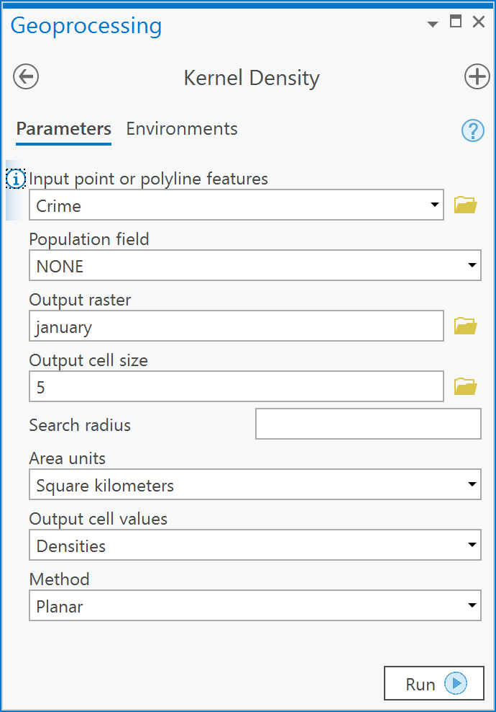

1. Set critical environment settings for the tool-level by selecting the Environments tab and fill in the following:

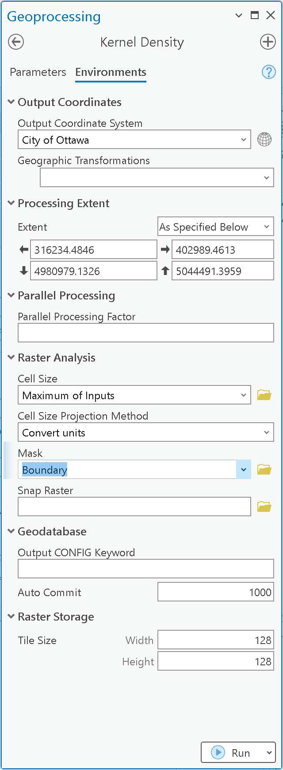 

1. Repeat 3-6 for February 1999 calling the output KDE ‘february’.
2. To compare two or more KDE estimates, the **z-scales are the same** **on both maps must be the same, o**therwise a color value such as the darkest blue on one map would not correspond to the same magnitude of density on the other – likewise with any color on the z-scale. The easiest way to make two maps with the same z-scale is to use the Apply Symbology from Layer geoprocessing tool to import the symbology of an existing layer you have already created a classification for. In the case of the assaults, I import from the layer that has the maximum density, which in our case is January, so I import January’s symbology to February’s:

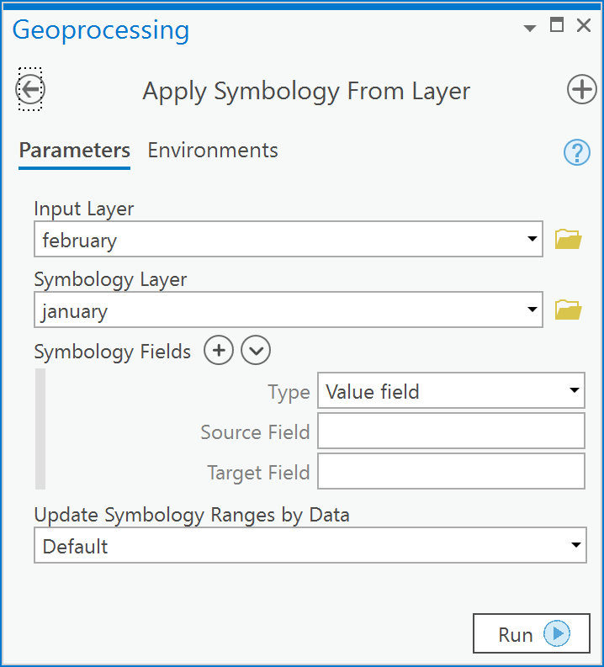

1. Your results (Figure 5) allow you to compare the two months intensity surfaces.

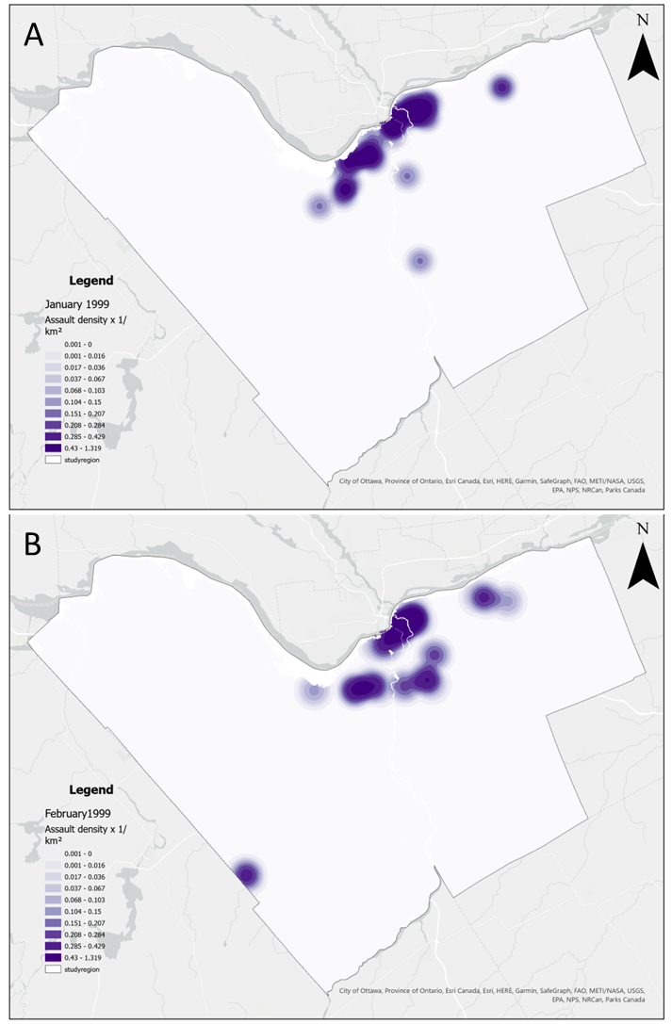

Figure 5: Kernel density estimates for assaults in A) January 1999; B) February 1999

You can see that the intensity is higher between the Rideau River and Rideau canal in January 1999 when compared to February 1999 (Figure 5). In addition, there is more spread to the intensity values in February 1999 (Figure 5). These observations are consistent with the standard distance observations in EX Q4, the higher intensity in the same location in January 1999 leads to a smaller standard distance, whereas the more diffuse intensity in February 1999 leads to a larger standard distance.

Another, more efficient way to compare to maps of the same variable is to compute the difference between them. Think about it. When comparing two quantitative maps you are concerned with where they are different and where they are the same. A difference map can help to quickly identify incongruities between two time periods. We can easily compute the difference between the assault densities between January and February using the Python tool in ArcGIS Pro.

1. Go to the Analysis tab and click on the Python button.
2. Enter the following lines except for the ones preceeded by a # which are comments for you to read in order to understand what the python statements mean.

*# Import the spatial analyst toolbox  
# so we can call tools by their name***from** arcpy.sa **import** *  
  
*# Create python raster variables from  
# the january and february rasters*jan = Raster(**'january'**)  
feb = Raster(**'february'**)  
  
*# Compute the difference between January and  
# February and make a new layer called diff*diff = jan - feb

1. The result will be a map of differences. Where the map has positive values, January had a higher intensity of assaults than February. Where the values are less than zero, February had a higher intensity of assaults,

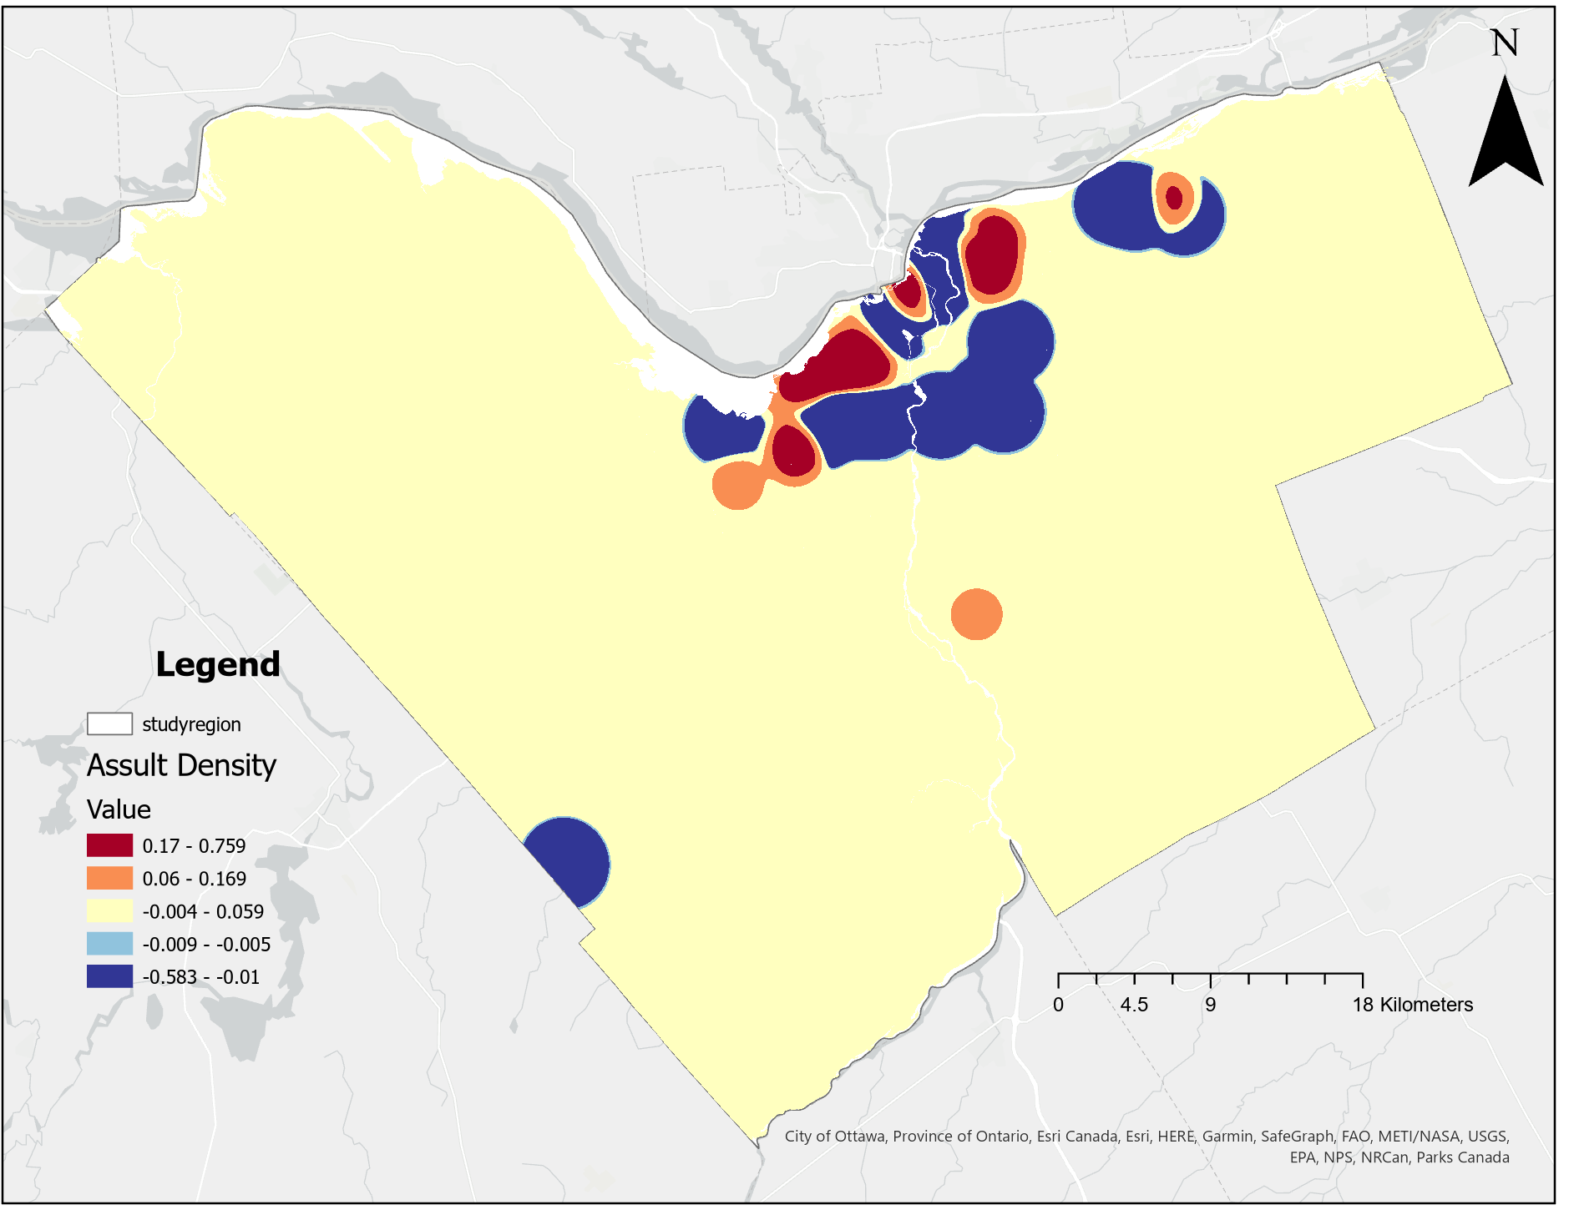

Q6: How do I calculate assaults per unit area within a region?

In Lecture 6 you were introduced to some point-polygon relations. One common relation that is used is to examine the density of points within polygons. To do so requires that you count each point within each polygon and then divide that count by the area of the polygon to arrive at a measure of points per unit area. This type of operation is easily done in GIS because point-in-polygon is a common operation. To count the number of points in any number of polygons within the same spatial domain, you only need to undertake a spatial join using the Spatial Join tool in ArcToolbox in order to undertake spatial joins when you only want to utilize the selected records from a query within the spatial join operation.

Suppose that you want to calculate, within Ottawa neighborhoods, the density of assaults from January-March 1999 (inclusive) and compare this with the dispersion of assaults in June-August 1999 (inclusive):

1. Create a query on the Crime layer for assaults between January 1999 and March 1999,

OCCDATE >= date '01/01/1999' AND OCCDATE < date '04/01/1999' AND SUMMARY = 'Assault'

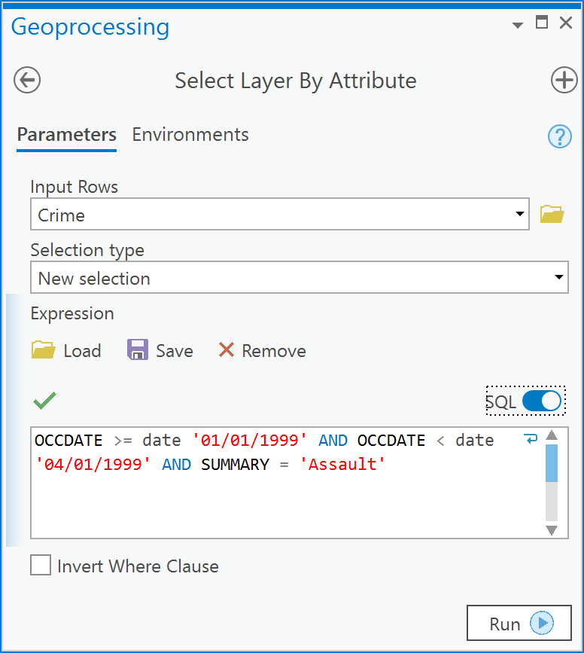

1. Go to Analysis Tools -> Overlay -> Spatial Join. The ‘Target Features’ will be the polygon layer **Boundary** which contains the Neighborhoods, the ‘Join Features’ is the **Crime** layer containing the selected records from the query in Step 1 above. The ‘Output Feature Class’ should be called **Neighbourhood_Assaults**. Put a check mark in the ‘Keep All Target Features”. Under ‘Field Map of Join Features’, delete all fields except ‘names’ which will retain only the neighborhood name in the output. This tool will automatically create a ‘Join_Count’ field in the output feature class that contains the number of points found in each neighbourhood polygon in **Boundary**. Before clicking Run, ensure your Spatial Join dialog options are the same as those below:

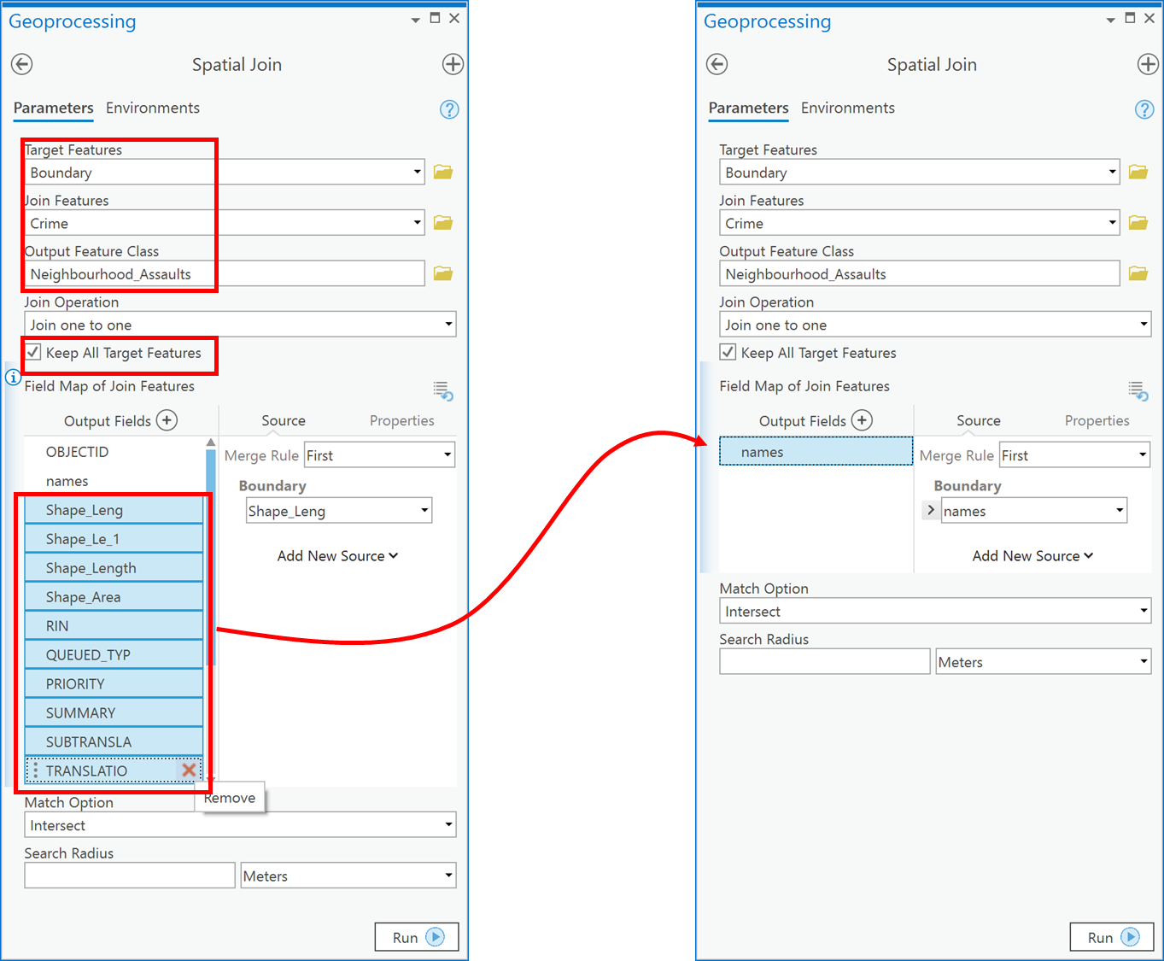

1. You will now have a new feature class in your table of contents. Open the attribute table for the new feature class and you will see the following table with a new field called ‘Join_Count’ that contains the number of assaults within each neighborhood. The ‘Shape_Area’ field contains the area of each neighborhood in the map units (m2) of the current coordinate system (which is the same coordinate system by default as the target layer):

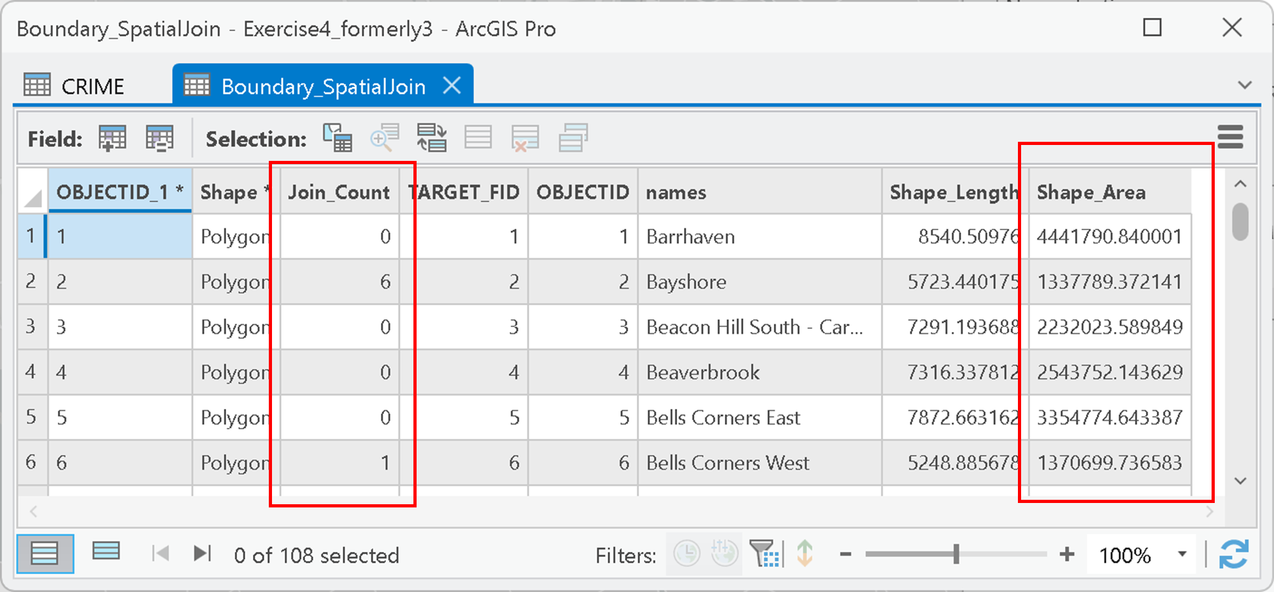

1. Next add a new field to the table called ASSDENS for assault density and make it of type double (Review EXERCISE 2 if you do not remember how to do this).
2. Now, calculate, in the ASSDENS field, the assault density in persons per square kilometer using an expression such as:

!Join_Count! / ( !Shape_Area! / 1000**2)

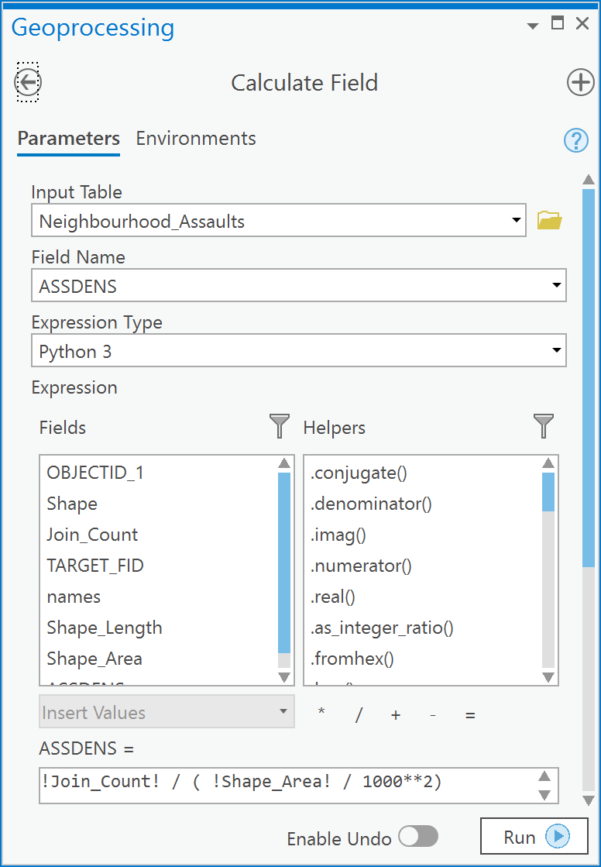

1. Next, create a choropleth map of the Assault density using the ASSDENS field. Click on the Neighbourhood_Assaults layer in the Contents pane. Then in the Feature Layer ribbon, choose the Appearance tab. In the Drawing group click on the Symbology button and choose Graduated Colors. In the Symbology pane, under ‘Field’ choose ASSDENS by choosing Graduated colors in the Symbology tab, e.g.:

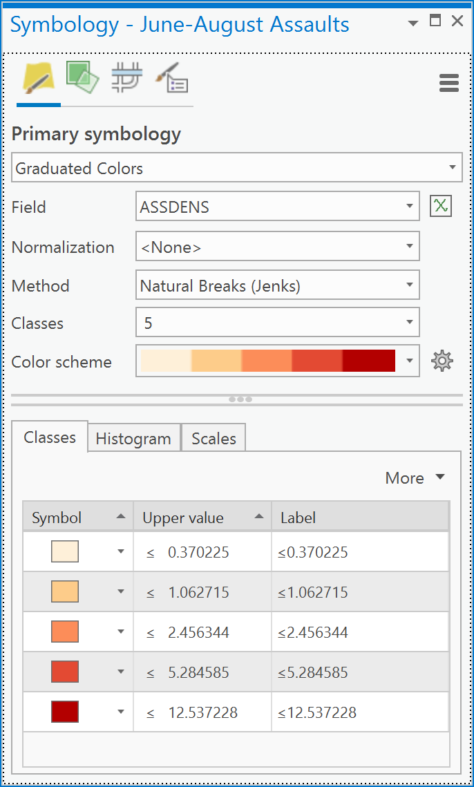

1. Repeat steps 1-6 for June-August 1999 (inclusive).
2. The results (Figure 6) allow you to compare the density by neighborhoods between the two timer periods.

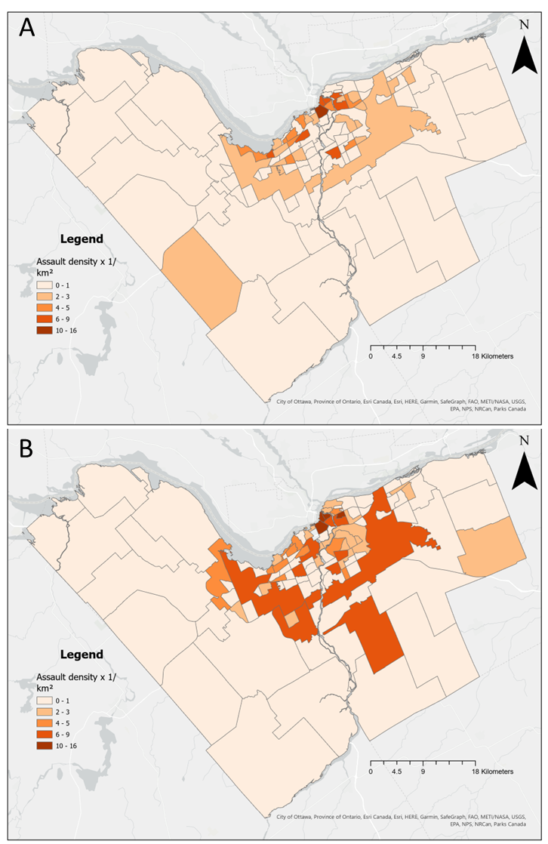

Figure 6: Assaults in Ottawa Neighborhoods in A) January-March 1999; B) June-August 1999

Notice again, that when comparing two maps of density, the z-scale of assaults per square kilometer is the same for both maps (Figure 6), otherwise the same color on each map would represent a different value and that would lead to incorrect comparisons. Overall the patterns in the two seasons are quite similar, however, the density of assaults is higher in more neighborhoods in the summer in central Ottawa when compared to winter. The pattern in summer also exhibits more spatial similarity in the central neighborhoods.

This example took a number of steps and these could be completed in the Python pane as well. The advantage again being that to complete the same analysis for another time window, you would only need to change the values in the statements that are highlighted in yellow:

*# Import the management & analysis  
# toolbox tool functions.***from** arcpy.management **import** *  
**from** arcpy.analysis **import** *  
  
input_lyr = **'crime'**query_string = **"OCCDATE >= date '01/01/1999' AND OCCDATE < date '04/01/1999' AND SUMMARY = 'Assault'"**nbrhoods = **'Boundary'**spatial_join_output = **'Neighbourhood_Assaults'**density_field_name = **'ASSDENS'**field_to_keep = **'names'***# First, select the assaults using the SQL where  
# clause held in query_string*SelectLayerByAttribute(input_lyr, where_clause=query_string)  
  
*# Create a field mapping object. This is complex but  
# the idea is that this ensures that only the  
# neighbourhoood names are transferred in the spatial join.*fm = arcpy.FieldMap()  
fms = arcpy.FieldMappings()  
fm.addInputField(nbrhoods, field_to_keep)  
of = fm.outputField  
of.name = field_to_keep  
fm.outputField = of  
fm.mergeRule = **'first'**fms.addFieldMap(fm)  
  
*# Spatially join the selected crime points  
# to the neighbourhoods and transfer  
# only the names field to the output  
# using the fieldmapping variable fms*SpatialJoin(nbrhoods,  
 input_lyr,  
 spatial_join_output,  
 **'JOIN_ONE_TO_ONE'**,  
 **'KEEP_ALL'**,  
 field_mapping=fms  
 );  
  
*# Add a field called "ASSDENS" to the spatially  
# joined layer*AddField(spatial_join_output,  
 density_field_name,  
 **'DOUBLE'** );  
  
*# Now calculate the field as the number of  
# assaults per square kilometer*CalculateField(spatial_join_output,  
 density_field_name,  
 **'!Join_Count! / ( !Shape_Area! / 1000**2)'** );

Q7: How do I create a union overlay and why?

**NOTE**: Create a new ArcGIS Pro map before starting this example. Also, if you have kept ArcGIS Pro open from the previous example(s), ensure you reset the Geoprocessing Environments-> Processing Extent back to option ‘Default’. **If you do not do so** then the spatial extent of Ottawa will apply for all analytical outputs and this will lead to you not seeing the results at the scale of North America.

In Lecture 6 you were introduced to the intersection and union overlay. A union overlay is used when you want to determine the geometric union of any number of polygons. The output of a union operation will “contain polygons representing the geometric union of all the inputs as well as all the fields from all the input feature classes” (ESRI). Thus, a union combines both polygons and their attributes (Figure 7). In Figure 7, there are two layers, one layer has an orange polygon with an attribute ORANGE and a green polygon with attribute GREEN. The second layer is a yellow triangle with the attribute YELLOW. When the yellow polygon is unioned with the orange and green polygon layer, wherever the yellow polygon intersected the orange polygon, the attributes of ORANGE and YELLOW are combined, and a new polygon is created with the two attributes ORANGE and YELLOW in two separate fields. By examining the unioned attribute table we can see which of the new polygons generated intersected because they have values in both new polygon’s attributes. The exact same process is true for the yellow and green polygon intersection. Where there were no intersections taking place, the new polygons generated simply has either an attribute that is ORANGE or GREEN.

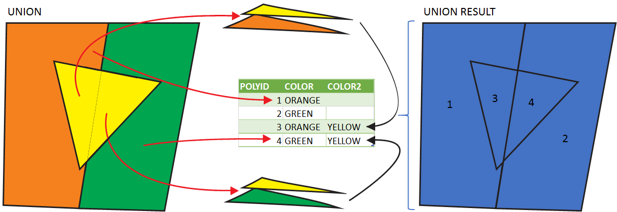

Figure 7: Geometric union example

If you were studying tree species richness (the number of different types of species in a given area) in North America, you could union overlay a set of polygons that represent range boundaries for different species.

Consider three range boundaries (Figure 8), for three species of Walnut (*Jugulans* spp.) in North America (from <https://www.fs.fed.us/nrs/atlas/littlefia/species_table.html>), namely Black walnut, White walnut and Little walnut. These are added to ArcGIS Pro from the TREES feature dataset in the OTTAWADATA.gdb file geodatabase in the Lecture7/Data folder. Each of the walnut layers contains a set of polygons. In the attribute table for each layer, there is a field called CODE that specifies the value of ‘1’ for each of the polygons in each layer (Figure 8). Placing these three layers into a union overlay processes produces a new polygon layer (Figure 8). The new unioned polygon layer has a set of new polygons and a new attribute table. The new attribute table contains the combined set of attributes for all the input layer attribute tables. Specifically, you can now see the combination of CODE fields (Figure 8). The value of CODE was ‘1’ in each of the input layers for each input polygon and thus, for a given output polygon in the unioned layer, a value of ‘1’ in any one of the three unioned CODE fields (CODE, CODE1, or CODE2) signifies that, for the unioned polygon in question, one of the three input layers contained a tree species at that given location (If you had undertaken an intersection overlay of the three input layers, the only polygons returned would be ones in which all three input layers contained a polygon). A new field can be added to the unioned table called “SUMCODE” and, when calculated as the sum of the individual unioned CODE fields, this represents the number of species of walnut that overlap in each unioned polygon.

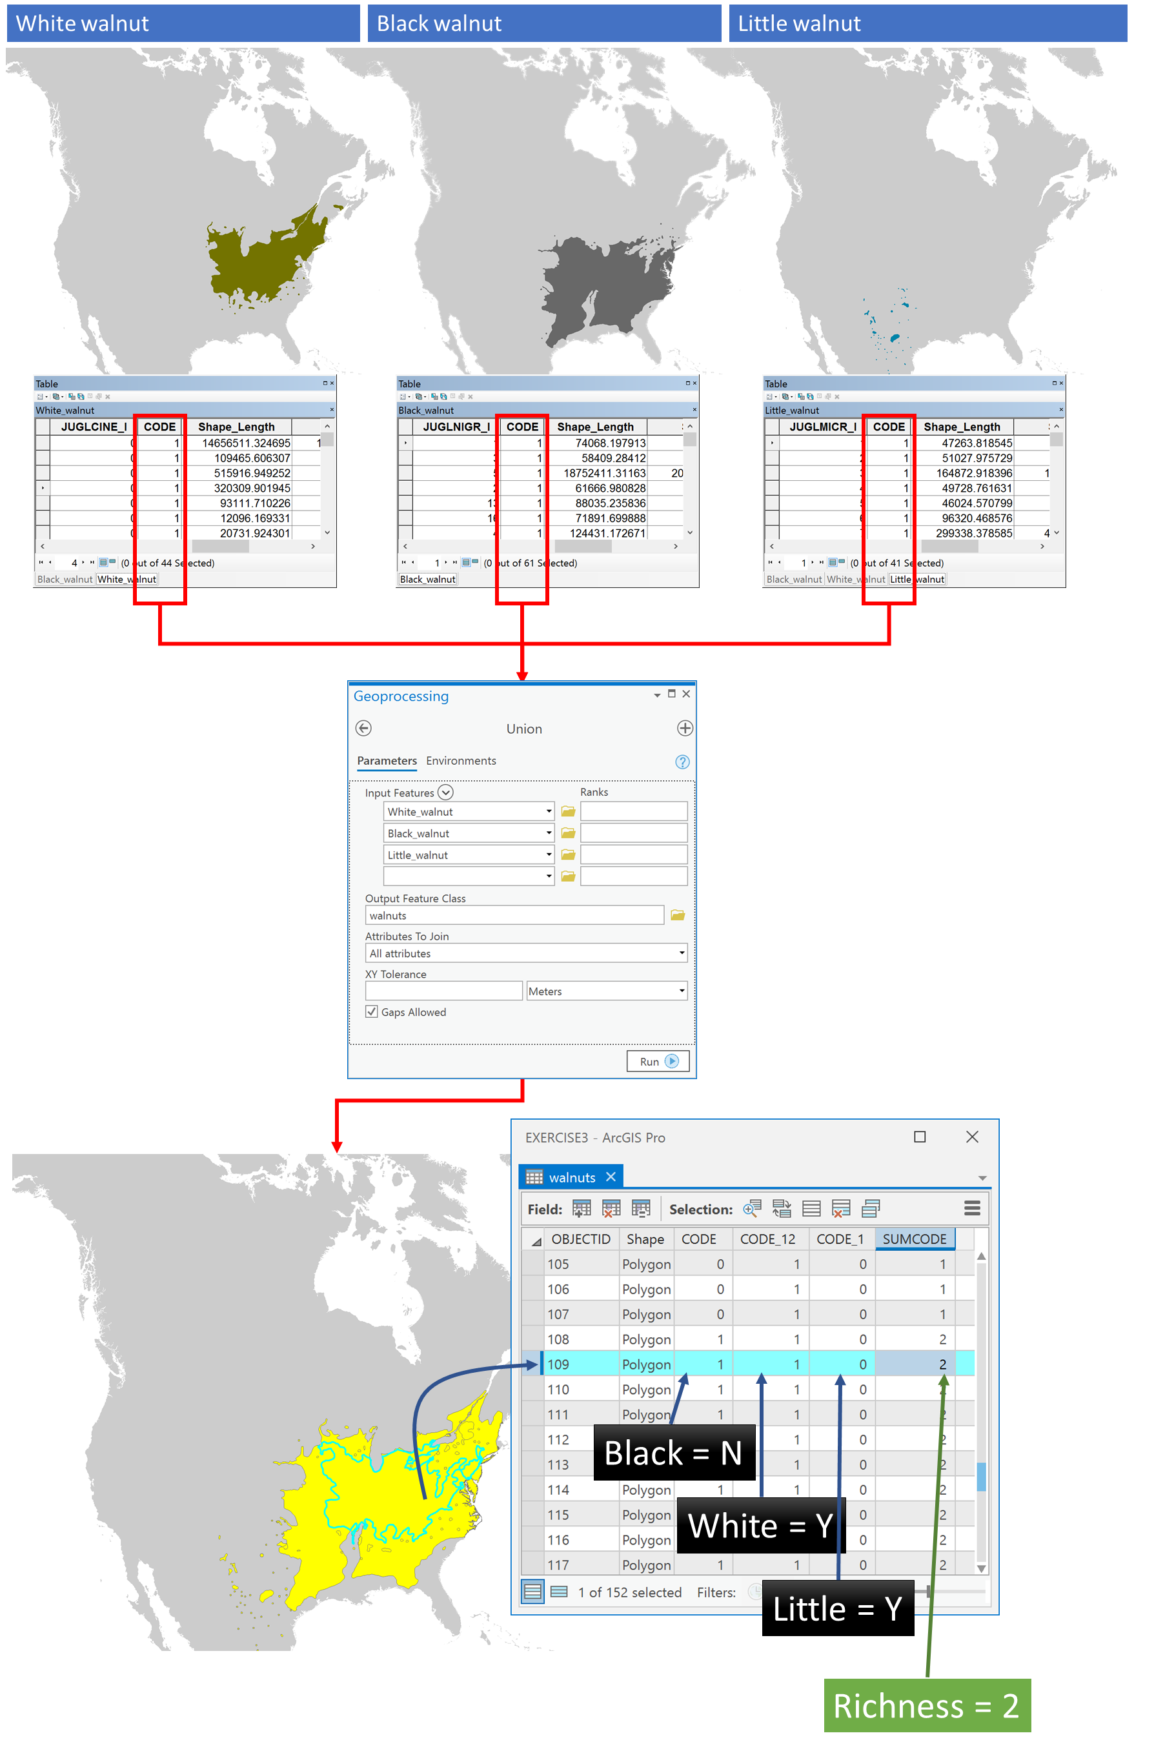

Figure 8: Process example of union overlay combining geometry and attributes in the output for three species of walnut (Jugulans spp.)

To try this process for yourself:

1. Add the following layers to ArcGIS Pro:

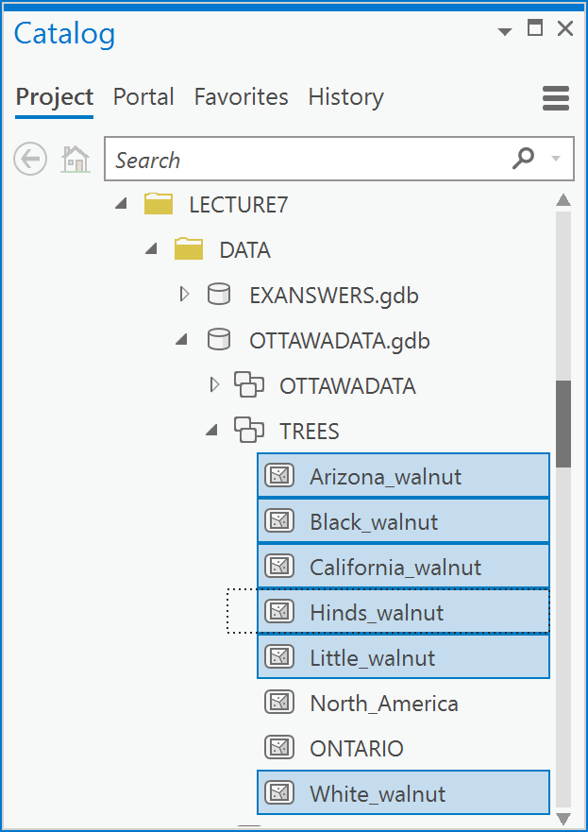

1. Choose Analysis Tools -> Union in the Geoprocessing pane.

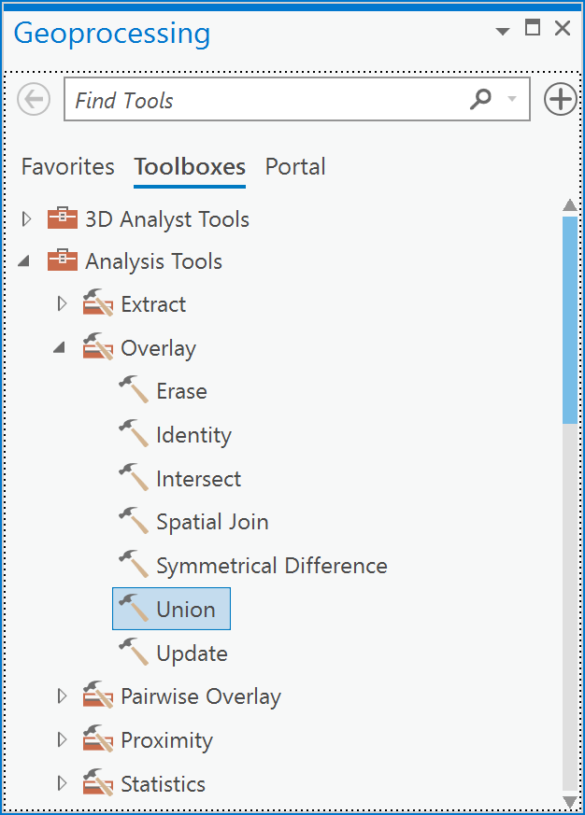

1. In the Union dialog box, add the six input layers and call the output ‘walnutunion’,

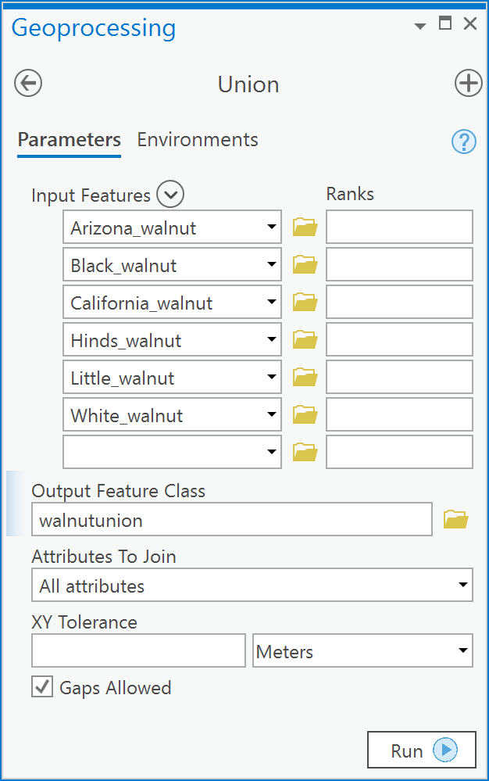

1. Open the attribute table for the resulting layer (Note that you will see many more fields than this because I have, in the fields view, turned off all fields but the CODE fields)

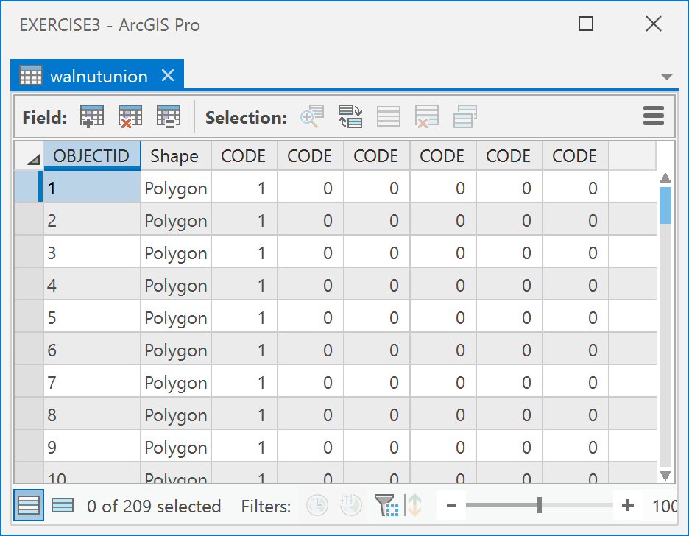

1. Add a new field called “RICHNESS” of type “Long Integer”.

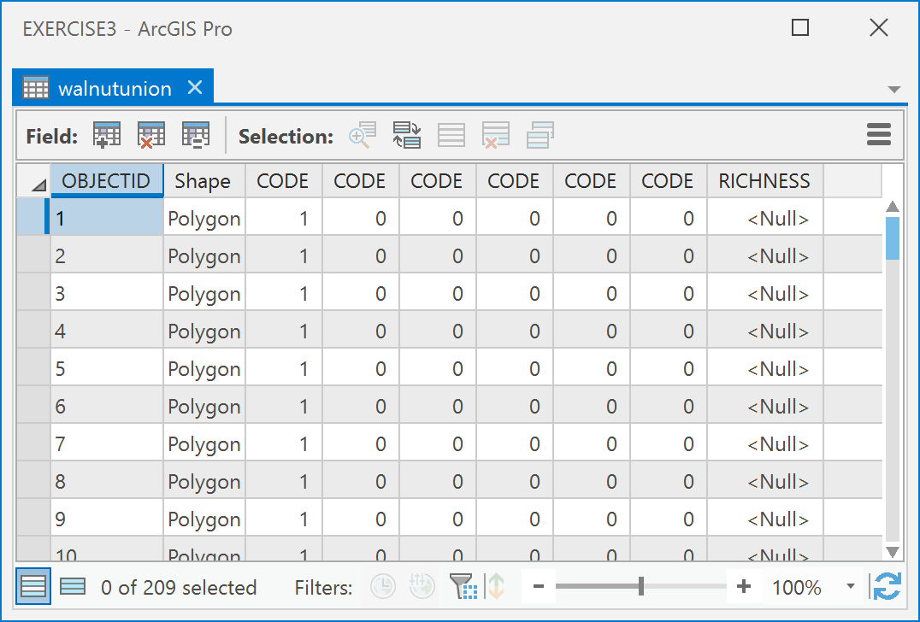

1. Calculate the new field as the sum of each of the CODE fields (CODE, CODE_1, CODE_12). Use a python statement such as:

!CODE! + !CODE_1! + !CODE_12! + !CODE_12_13! + !CODE_12_13_14! + !CODE_12_13_14_15!

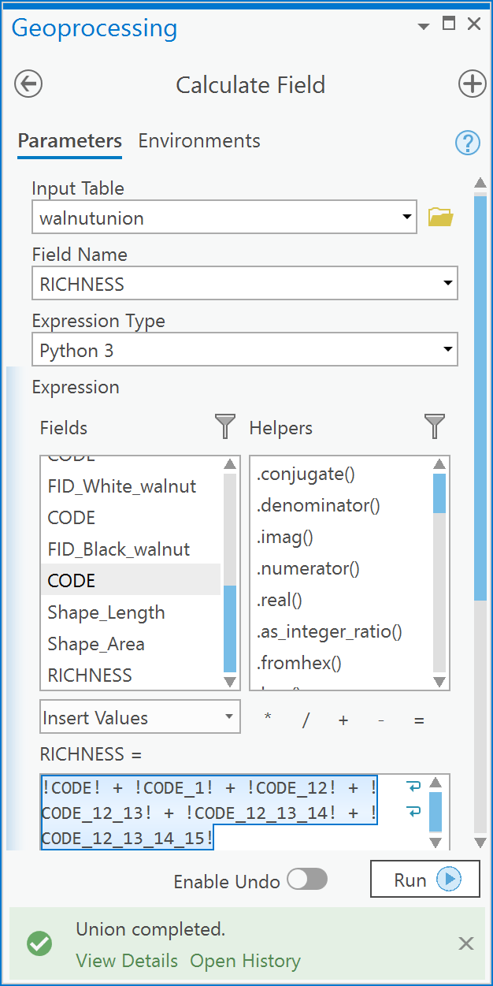

In the field calculator. Remember, an attribute table cannot have two fields of the same name in the same table, thus, when the union process occurs, the original fields called “CODE” in the input layers to the union process are automatically renamed by ArcGIS by appending a “_1” or “_12” etc…

1. Create a choropleth map using a quantitative symbology,

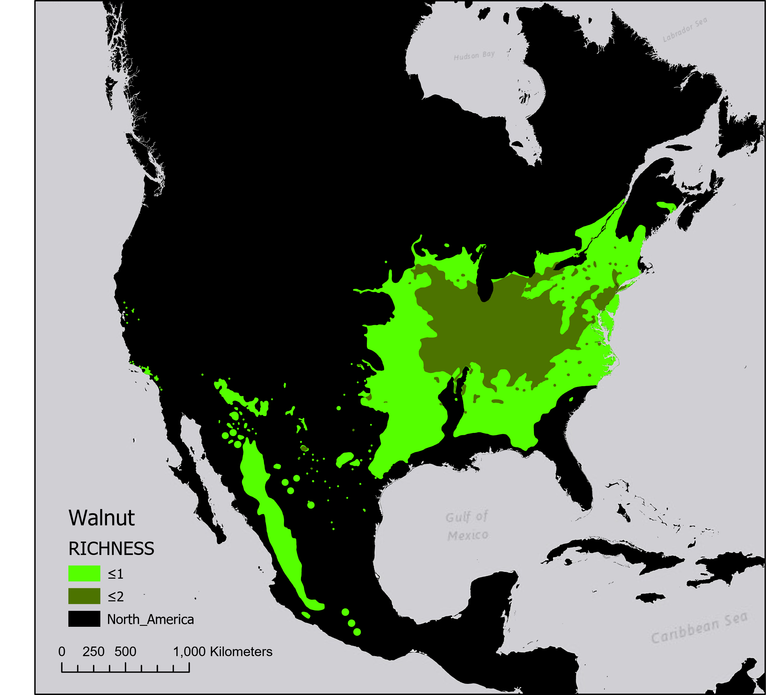

Like our other examples, we could also formulate a set of Python statements to complete this task. This one is a little more complex and you may not fully understand all the statements and that is OK. The advantage of such a set of python statements is that you would only need to change the highlighted statements to create a species richness column for any number of trees.

*# Import the management & analysis  
# toolbox tool functions.***from** arcpy.management **import** *  
**from** arcpy.analysis **import** *  
  
*# Define output feature class name  
# and species richness field name*out_fc=**"walnuts"**richnessfld=**"RICHNESS"***# Create a list of layers to union*input_features=[**'White_walnut'**,  
 **'Black_walnut'**,  
 **'Little_walnut'**,  
 **'California_walnut'**,  
 **'Arizona_walnut'**,  
 **'Hinds_walnut'**];  
  
*# Union all the tree layers keeping all  
# attributes because we need the CODE  
# field from each*ulayer=Union(input_features,out_fc,**"ALL"**)  
  
*# Create a list of field names because  
# we don't know how many layers will  
# be unioned, nor what all the CODE  
# fields will be named during the   
# union process. We only know that  
# they will start with the string  
# 'CODE'.*fldlist=[**"!{}!+"**.format(fld.name) **for** fld **in** arcpy.ListFields(ulayer,**"CODE*"**)]  
  
*# Create the field calculator expression  
# which will be like '!CODE!+ !CODE_1!+...'*calcexpr=**' '**.join([s **for** s **in** fldlist])  
calcexpr=calcexpr[0:-1]  
  
*# Add a field called "RICHNESS" to the  
# unioned layer*AddField(ulayer,  
 richnessfld,  
 **'LONG'** );  
  
*# Now calculate the field RICHNESS  
# using the expression string  
# stored in calcexpr*CalculateField(ulayer,  
 richnessfld,  
 calcexpr  
 );

Answer the following questions.

Each of the questions requires an explanation - so read carefully. Each question requires a map as part of the answer, and this must be a correct presentation map (excluding the graticule is ok but not necessary). Ensure you review Section 2.3 of the style manual that is found at the beginning of Exercise 1 or 2.

1. [2 points] Using standard distance circles and mean centers, compare the distribution of accidents (‘Accident’ in the SUMMARY field of the Crime feature dataset) between winter and summer in Ottawa in 1999. Define winter as January to March and summer as June to August. Present a map of the results and explain what these results tell you about the distribution of accidents between seasons.
2. [2 points] For the same winter and summer periods in (1), create KDE estimates for accidents in each season. Compare the maps for each season.
3. [5 points] As part of your job at the City of Ottawa, you are asked to determine which areas of the city should be targeted for selective tree injections of TreeAzin, a systemic insecticide, that kills Emerald Ash Borer larvae. The injection programme is selective and targets “ash tree protection in neighbourhoods with a high percentage of forest cover from ash species” (<http://ottawa.ca/en/residents/water-and-environment/plants-and-animals/invasive-species>). Go to the City of Ottawa Open Data website and search for the “Tree Inventory”. Download and unzip the shapefile. Import that the shapefile into your OTTAWADATA.gdb geodatabase (in the Lecture7 folder). Calculate the density of Ash trees (***trees / km2***) in Ottawa Neighborhoods. Use the neighborhoods feature class in the OTTAWADATA.gdb/OTTAWADATA feature dataset. In calculating density, ensure you only include *Fraxinus* spp. when creating your query, use a query statement such as:

"SPECIES" LIKE 'Fraxinus%'

to select only Ash species. Present a map of the density of ash trees in Ottawa neighborhoods. Provide an explanation of the pattern of Ash tree density in Ottawa. Based on the observed pattern, what recommendation would you provide the city manager regarding the injection programme?

1. [2 marks] Present a KDE estimate for the same Ash trees in (3) and compare the results with (3). What are the similarities and differences you notice? Why might there be similarities and differences based on the methods used to calculate density vs. intensity? Would your recommendations change or stay the same? Why? (Hint, it may be informative to overlay the neighbourhood boundaries with no color fill on top of the KDE surface).
2. [4 marks] Download the shapefiles for all the *Fraxinus* spp. found at <https://github.com/wpetry/USTreeAtlas>. There are 16 species in total. You might want to download the entire repository as a zip file and then unzip it so that you can easily access the folders for each species - rather than downloading each individual species. To do so just click on the green button and choose Download Zip:

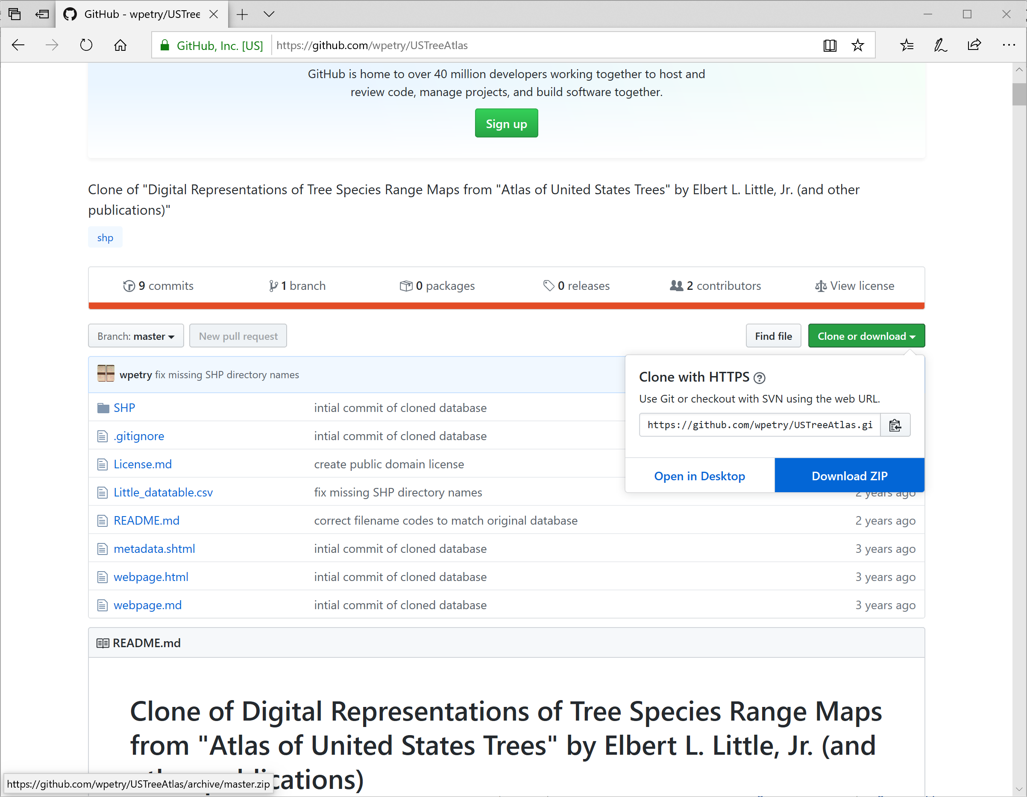

Using the union overlay tool, create a map that shows the species richness of *Fraxinus* in North America (any folder that starts with “Frax…” in the github repository. Note that you will need to use the Define Projection tool for each of the files you download. The information on the coordinate system is on the GitHub page (the metadata). Present a map of *Fraxinus* species richness in the same coordinate system as the TREES feature dataset in the OTTAWADATA.gdb. Describe the pattern of *Fraxinus* spp. richness in North America.

1. The Crime layer is a synthetic layer representing calls-for-service (when someone calls 911) and does not represent actual crimes committed at the locations specified. At a small scale, the dataset is representative of the real patterns of crimes in Ottawa over the period of 1998-2001. It was created by using probability surfaces derived from actual calls for service over that time period specified. It is not locally accurate.